Project 3 Testing Document

Nobel Zhou (nxz157)

**30 October 2020**

Introduction

This the Project 3 testing document for all methods and classes. This chess program represents a playable game of chess, including promotion, check, checkmate, stalemate, draw by threefold repetition, and draw by 50 move rule. All moves are checked to make sure they don’t result in check. In addition, the chess board has been updated to add piece icons instead of just the symbol and the available moves are also highlighted when you click on the piece. There are a lot of methods that are unnecessary in the light of grading for this program but deemed necessary for the functionality and accuracy of creating a chess program. In addition, I will **not** be testing any methods that were pre-coded. I will, however, test any added methods to the ChessBoard or other given classes. In addition, I will be testing interface and abstract class methods through a concrete class because they are not available to be tested through their instances because they don’t have one. This testing document will be broken down and tackled within each class file. In addition, I have attached images containing the chess positions and the expected results of the resulting position if Junit is not feasible for testing those types of interactions. This is possibly the most I spent (and will ever spend) on a single programming project but my aim was to create a fully functional chess game instead of just being semi-functional. All chess board visualizations were taken using the analysis board at chess.com. Also, if you decide to run the testers, it WILL take a long time because it has to create a new chess board (and sometimes multiple) for each test. Also, the chess board windows do not go away but once you close one, all of them close. I’m sorry in advance for any inconveniences caused as a result of this.

A Quick Note on Interfaces and Class Hierarchy

As you can see, each piece is an extension of the abstract class ChessPiece. In addition, they implement a “Move” which includes a L move (for knights), diagonal move, vertical/straight move (called a “StraightMove”), king moves, castling moves, pawn moves, and even en passant moves. Note that a lot of these interfaces could be moved into the chess piece itself (barring the StraightMove and DiagonalMove, as they are shared by QueenPiece, RookPiece, and BishopPiece, or a combination of the two), especially the en passant, pawn, king, and castling moves, since they will probably not be implemented in any other novel chess piece; however, these are included so that if the programmer wants to create a new piece that wants to implement these moves (say, a super piece that could be both a queen and a knight’s functionality together), it is possible to do so. The programmer can even make a totally different move altogether by also extending NormalMove to make an entirely novel move.

You may have also noticed the presence of the Promotable interface. This interface only serves as a marker interface which indicates the ChessPiece that implements it can be promoted to from a pawn.

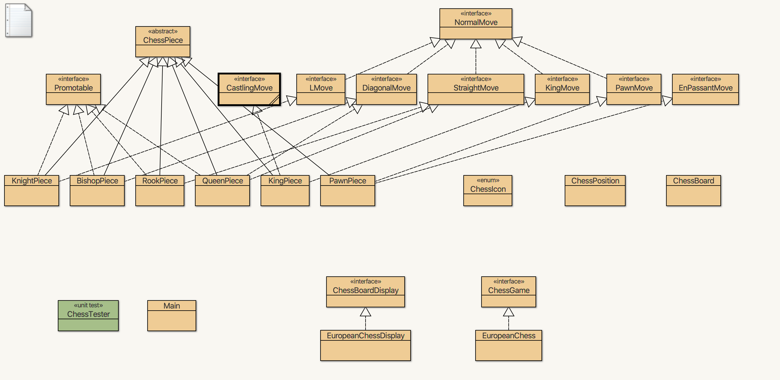

Figure : Class hierarchy of my chess program. Dashed lines indicate implementing interfaces while solid lines indicate extending classes.

With that, let’s get started!

ChessIcon

## Introduction

I will first start with the peripherals of the program. Since ChessIcon is an enum with a private constructor, I cannot test the actual constructor. I will test getting the icon heigh and get icon width once in the JUnit class since all of them have the same height and width, but then I will use the Java Interactions Pane (JIP) to create a new JFrame and add each of them sequentially to show that the icons are being correctly created.

ChessIcon::ChessIcon(), ChessIcon::getIconHeight()

, and ChessIcon::getIconWidth()

This will all be done in JUnit. I will first indirectly test that the constructor works by creating each of the pieces in order: white knight, white rook, white queen, white king, white bishop, white pawn, black knight, black rook, black queen, black king, black bishop, and black pawn. I will then only use the first piece (white knight) and make sure that the icon width and the icon height are correct.

The test is grouped under testChessIcon() in ChessTester.java::54-71. The test passed successfully.

ChessIcon::paintIcon()

This will all be in JIP. I will first create ChessIcon like I did in the previous test. I will then add each of them to a new JFrame. I will then display the JFrame.

JIP Code:

1. import javax.swing.JFrame;
2. import javax.swing.JLabel;
3. import java.awt.GridLayout;
4. ChessIcon whiteKnight = ChessIcon.WHITE_KNIGHT;
5. ChessIcon whiteRook = ChessIcon.WHITE_ROOK;
6. ChessIcon whiteQueen = ChessIcon.WHITE_QUEEN;
7. ChessIcon whiteKing = ChessIcon.WHITE_KING;
8. ChessIcon whitePawn = ChessIcon.WHITE_PAWN;
9. ChessIcon blackKnight = ChessIcon.BLACK_KNIGHT;
10. ChessIcon blackRook = ChessIcon.BLACK_ROOK;
11. ChessIcon blackQueen = ChessIcon.BLACK_QUEEN;
12. ChessIcon blackKing = ChessIcon.BLACK_KING;
13. ChessIcon blackPawn = ChessIcon.BLACK_PAWN;
14. JFrame frame = new JFrame("Test");
15. GridLayout layout = new GridLayout(2, 5);
16. frame.setLayout(layout);
17. frame.add(new JLabel(whiteKnight));
18. frame.add(new JLabel(whiteRook));
19. frame.add(new JLabel(whiteQueen));
20. frame.add(new JLabel(whiteKing));
21. frame.add(new JLabel(whitePawn));
22. frame.add(new JLabel(blackKnight));
23. frame.add(new JLabel(blackRook));
24. frame.add(new JLabel(blackQueen));
25. frame.add(new JLabel(blackKing));
26. frame.add(new JLabel(blackPawn));
27. frame.pack();
28. frame.setVisible(true);

 Result:

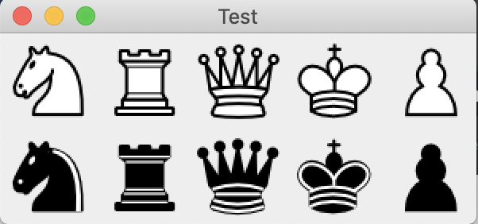

KnightPiece, LMove, NormalMove, and ChessPiece

## Introduction

This will cover all methods of the KnightPiece as well as the inherited methods of the ChessPiece, since I cannot create an instance of the ChessPiece. Of course, this means I can’t really test out the constructors of ChessPiece, but if the constructor of KnightPiece works, we can assume that the constructor of ChessPiece will also work. In addition, LMove is fundamentally important to KnightPiece, so for KnightPiece’s methods isLegalNonCaptureMove(int row, int column) and isLegalCaptureMove(int row, int column), I will first test NormalMove’s respective methods, then LMove’s respective methods and then test KnightPiece’s methods.

ChessPiece::ChessPiece(), KnightPiece::KnightPiece(), ChessPiece::setMoves(), ChessPiece::getMoves(), ChessPiece::getSide(), ChessPiece::getIcon(), ChessPiece::setLocation(), ChessPiece::getChessBoard(), ChessPiece::getRow(), and ChessPiece::getColumn()

The first test will deal with setters and getters as well as the constructors. I only need to test this once because there isn’t any logic involved. I will first initialize a KnightPiece using a ChessGame.Side, ChessBoard, row, and column. Then I will get the moves, side, label, icon, chess board, row, and column. I will then change the location to 7, 7 and check the row and column again.

The test is grouped under testChessPiece() in ChessTester.java::79-101. The test passed successfully.

ChessPiece::moveDone()

The second test will deal with the moveDone() function. I will make a new KnightPiece and call the moveDone() function, which should increment moves by one. I will then call getMoves(), which should now return 1.

The test is grouped under testChessPieceMoveDone() in ChessTester.java::108-114. The test passed successfully.

ChessPiece::equals()

The third test will deal with the equals() function. I will make a new KnightPiece. I will then make a BishopPiece with the same parameters. I will then check if these are equal, which they shouldn’t. I will then make another KnightPiece with the same parameters. If I test if they equal, this should return true. I will then call voidDone() which should still return true, because number of moves does not change if the pieces are equal, unless it results in a change in valid moves (like en passant, but we’re dealing with knights here). I will then set the location of the second KnightPiece to 0, 1 and then 1, 0 which should both return false when calling equals(). I will then add a KnightPiece of opposing side onto the second knight’s board at 1, 2 after resetting the location. This should return true, because this does not change the fact that it is still a valid move. I will then remove that knight and add a KnightPiece of the same color onto the second knight’s board at 1, 2. This should then return false because the knight won’t be able to capture the same side pieces, resulting in a change in legal moves. I will then make a third KnightPiece with same parameters, with the exception that it is a different side. This should return false.

The test is grouped under testChessPieceEquals() in ChessTester.java::121-149. The test passed successfully.

NormalMove::isValidNonCaptureMove() and NormalMove::isValidCaptureMove()

The fourth test will deal with the isValidNonCaptureMove() and isValidCaptureMove() function. I will make a new KnightPiece in the middle of the board (location: 3, 3). I will then both functions for all squares, plus 1 square off the chess board in each direction. The following setup was used for both functions:

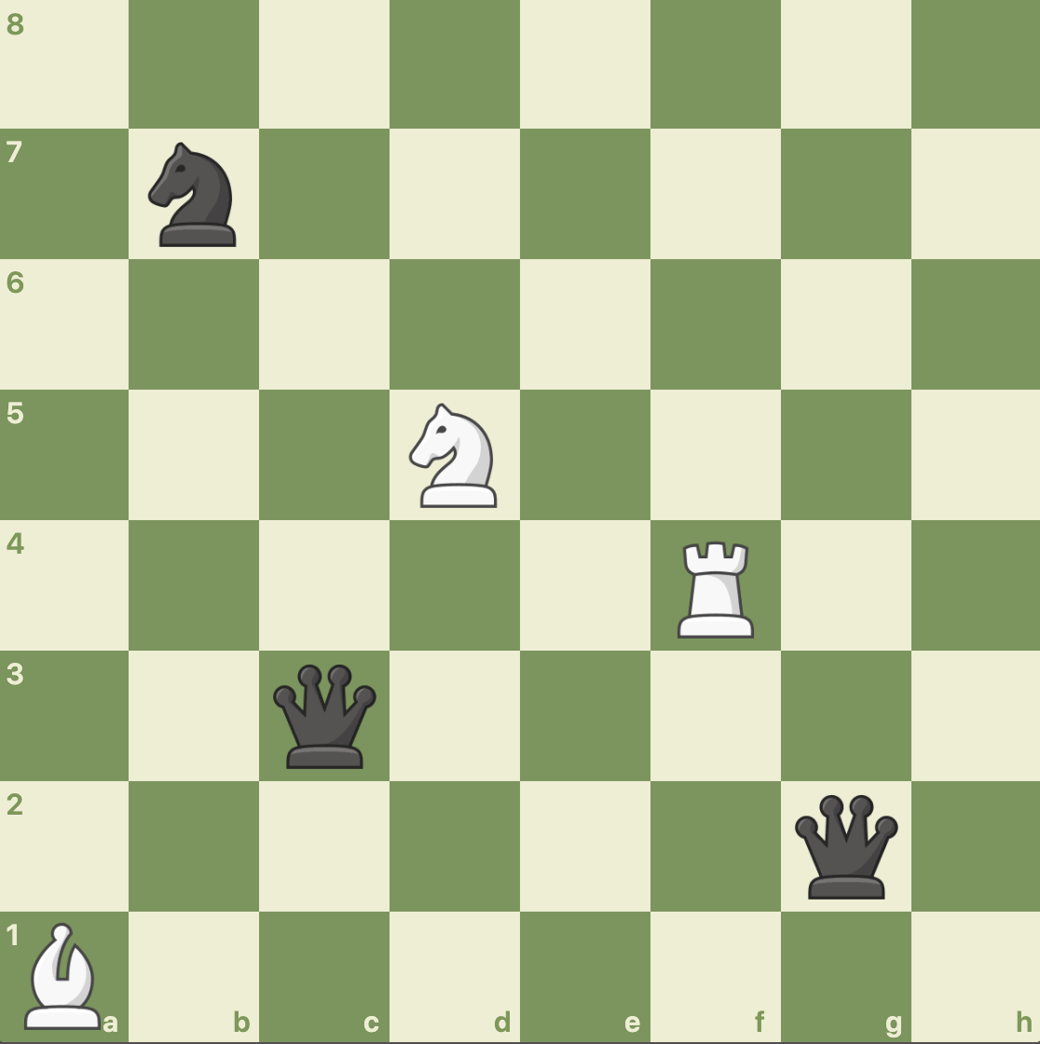

The red highlighted squares below should return true for isValidNonCaptureMove():

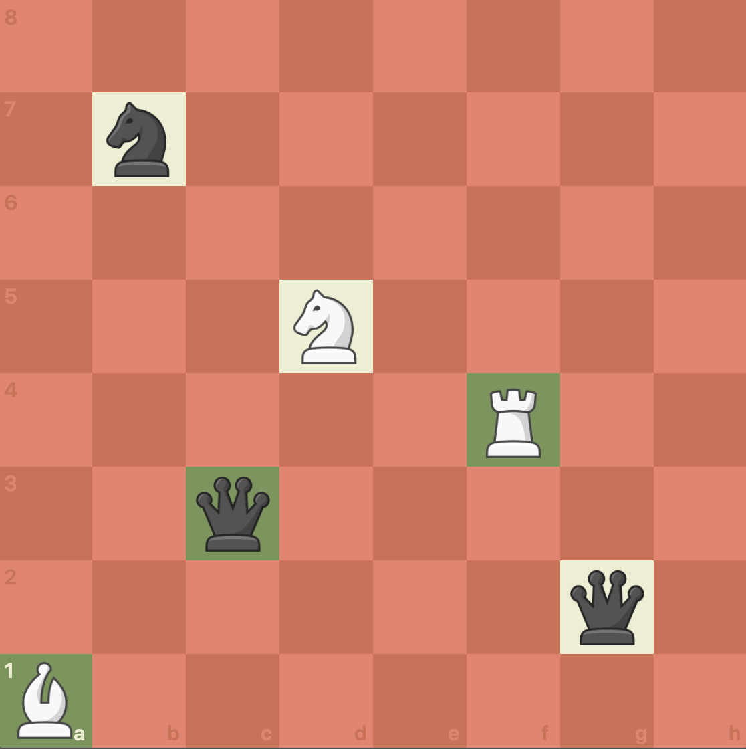

The red highlighted squares below should return true for isValidCaptureMove():

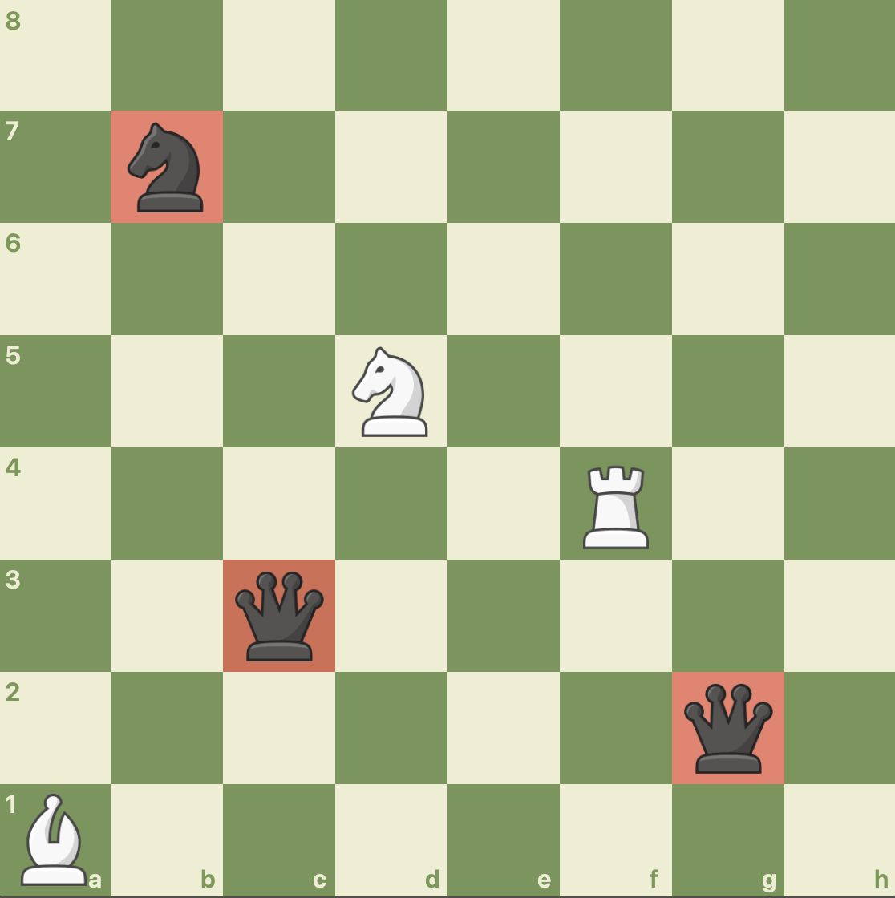

Note that this doesn’t actually check for the L moves. It just checks for if the squares are occupied and for captures if the piece occupying it is an opposite color/side.

The test is grouped under testNormalMove() in ChessTester.java::156-185. The test passed successfully.

LMove::isValidLNonCaptureMove() and LMove::isValidLCaptureMove()

For the fourth test, I will make a new KnightPiece in the middle of the board (location: 3, 3). I will then both functions for all squares, plus 1 square off the chess board in each direction. I will also use the same setup as the third test (testNormalMove()). I will then use the following setup to make sure that the knight will not allow moves off the board:

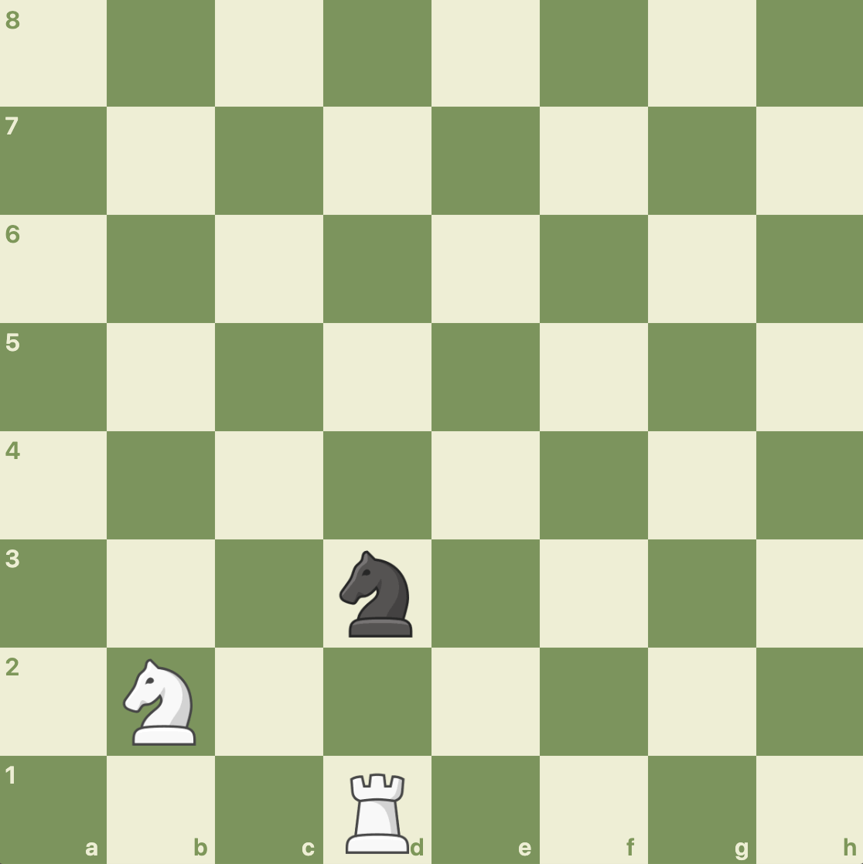

The red highlighted squares below should return true for isValidLCaptureMove():

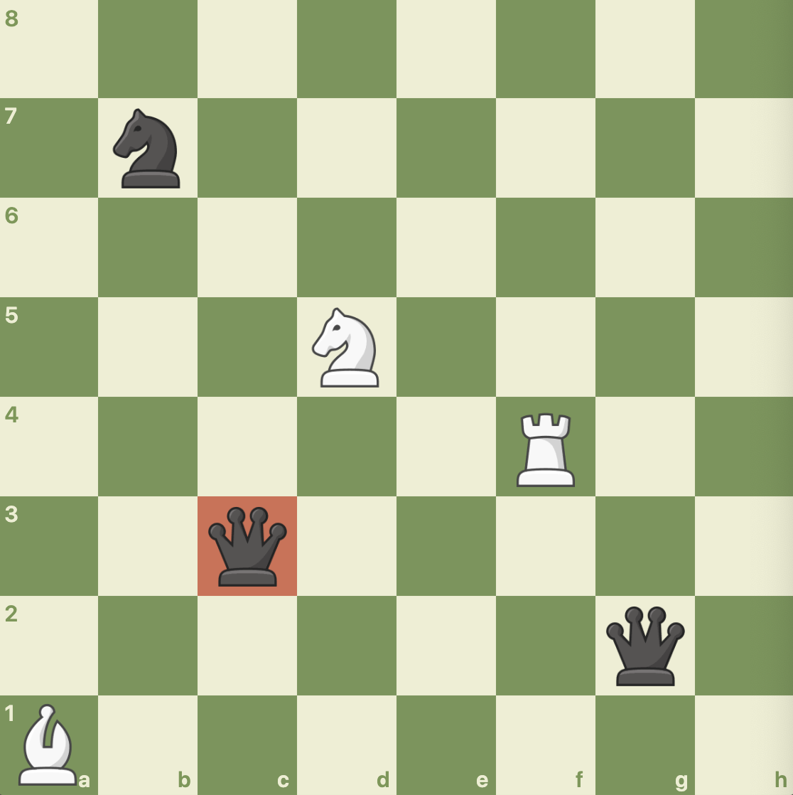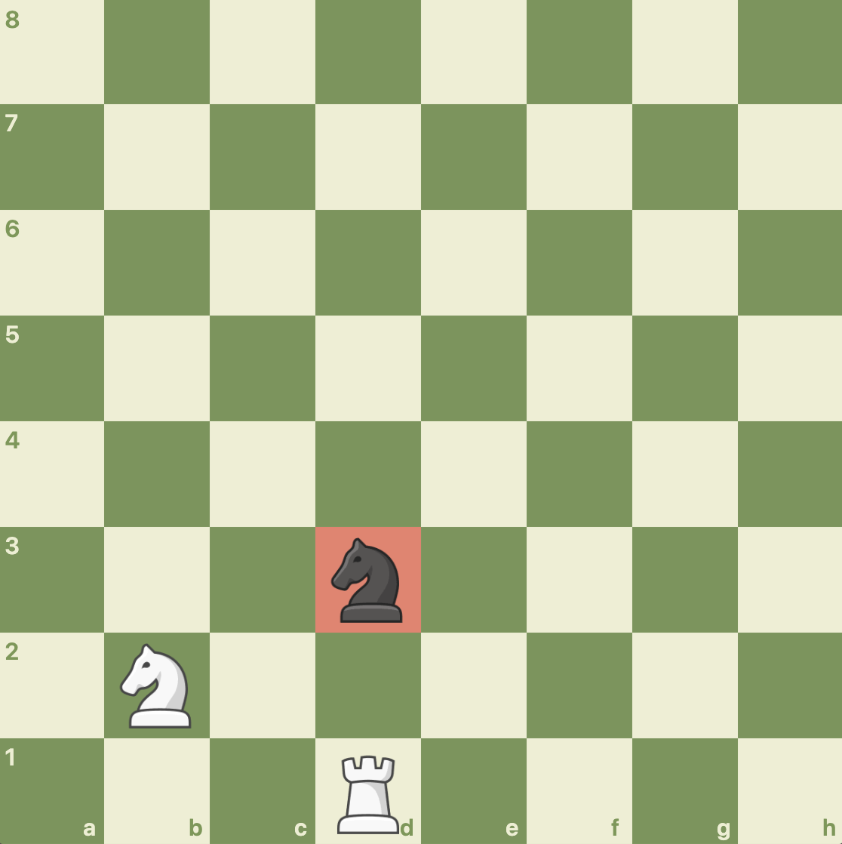

The red highlighted squares below should return true for isValidLNonCaptureMove():

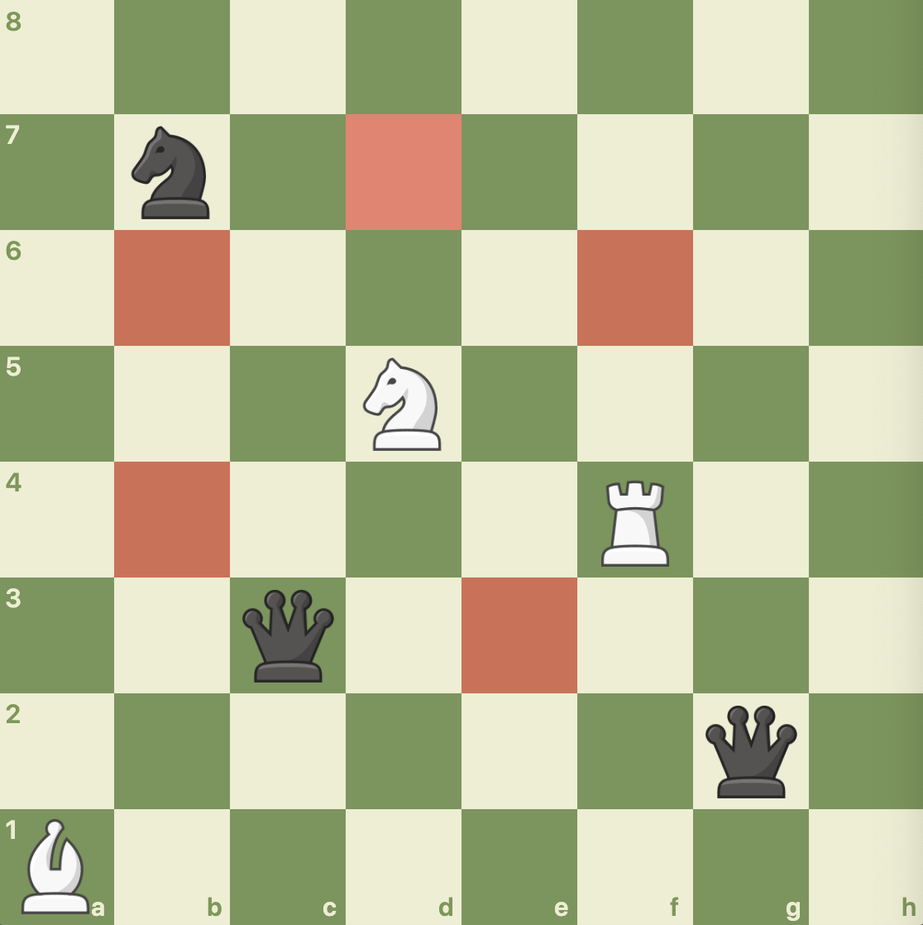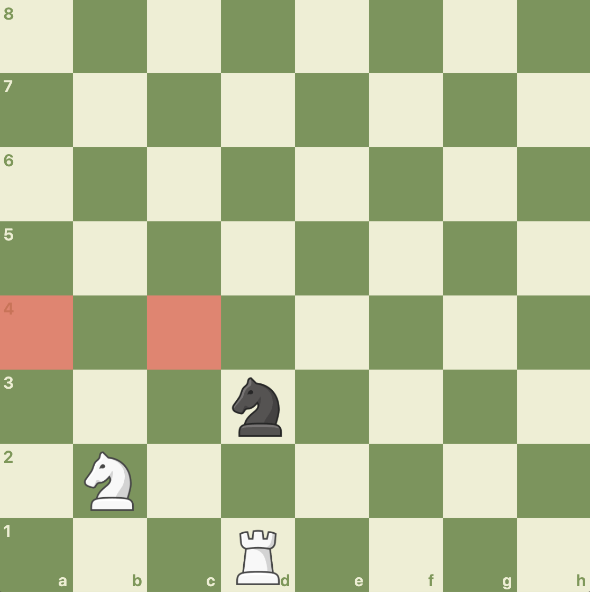

The test is grouped under testLMove() in ChessTester.java::193-250. The test passed successfully.

ChessPiece::isLegalMove(), KnightPiece::isLegalNonCaptureMove(), and KnightPiece::isLegalCaptureMove()

For the fifth test, I will test the 2 positions mentioned above in the fourth test. I will do this by using a KnightPiece to test the ChessPiece’s isLegalMove() since ChessPiece cannot be instantiated. I am not testing KnightPiece’s isLegalNonCaptureMove() and isLegalCaptureMove() separately because they are basically a repeat of LMove’s methods. For the 2 positions, the red highlighted squares below should return true for isLegalMove():

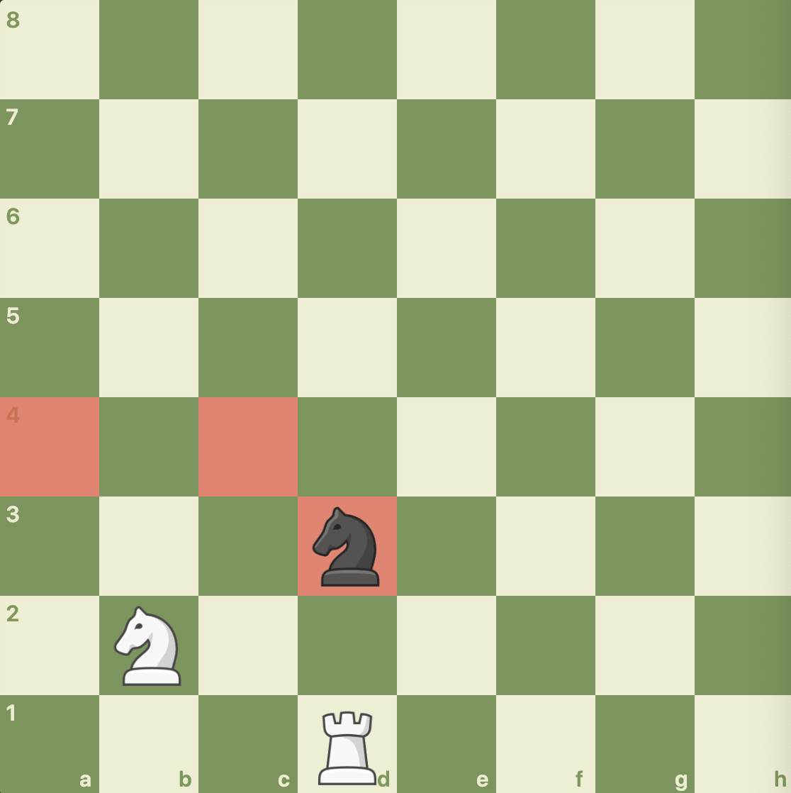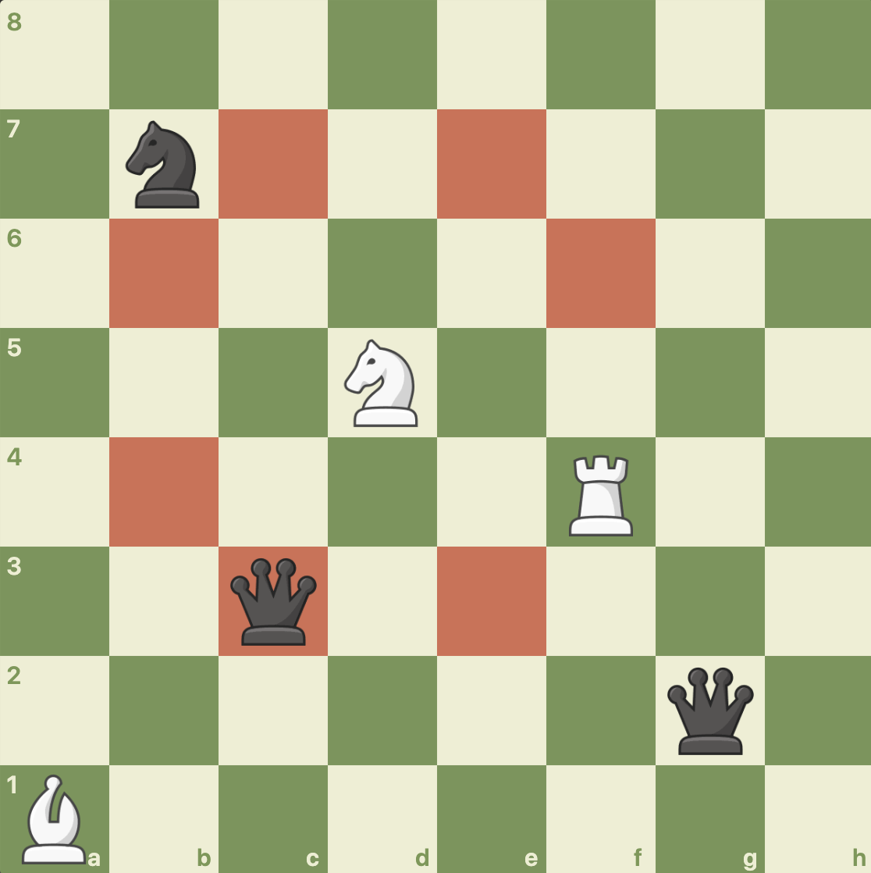

The test is grouped under testKnightPieceIsLegalMove() in ChessTester.java::257-299. The test passed successfully.

BishopPiece and DiagonalMove

## Introduction

This will cover all methods of the BishopPiece. In addition, DiagonalMove is fundamentally important to BishopPiece, so for BishopPiece’s methods isLegalNonCaptureMove(int row, int column) and isLegalCaptureMove(int row, int column), I will first test DiagonalMove’s respective methods and then test BishopPiece’s methods.

DiagonalMove::checkEmptyDiagonalMove()

For the first test, I will be testing the checkEmptyDiagonalMove() method which should return true if all of the moves up to the current square (including the current square) is empty. I will test 2 positions with only the red highlighted squares, listed below. This is because this method checks for empty squares between the squares but doesn’t actually check if the square passed into the function is a valid diagonal move or not. That is done by isValidDiagonalCaptureMove() and isValidDiagonalNonCaptureMove().

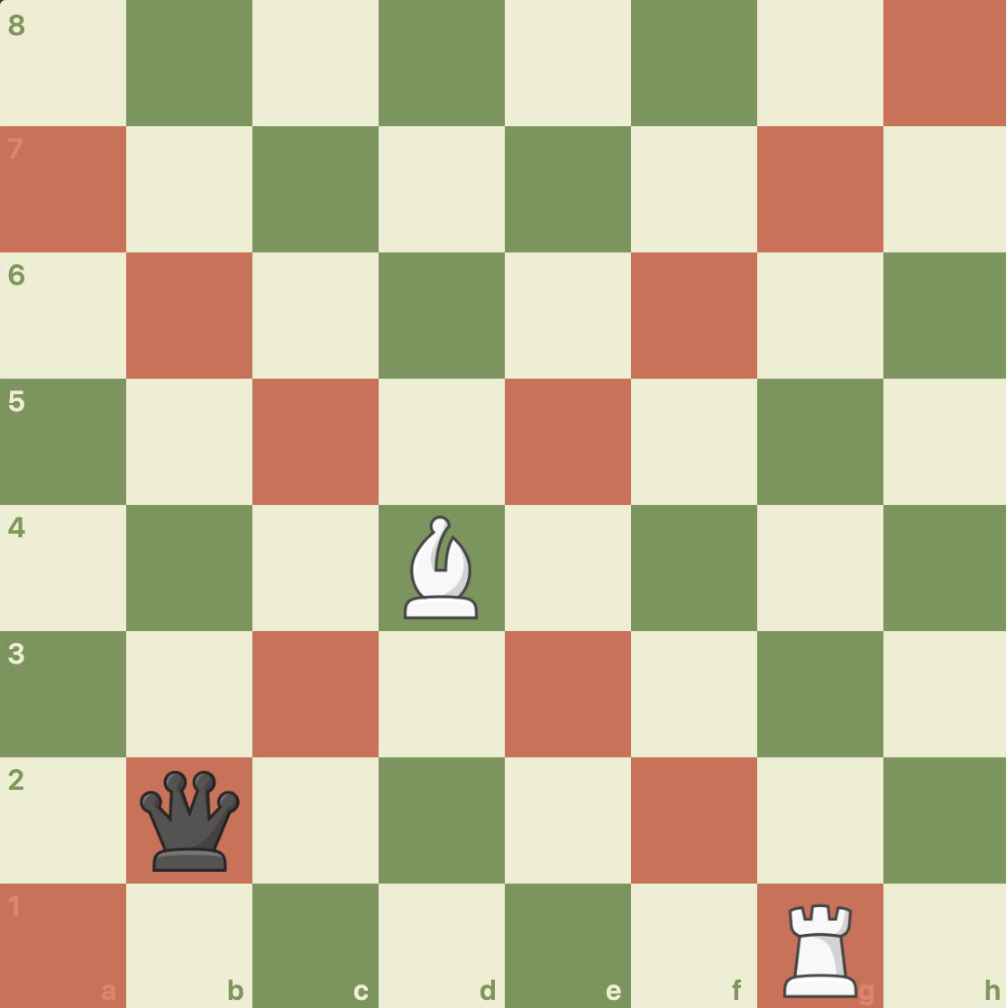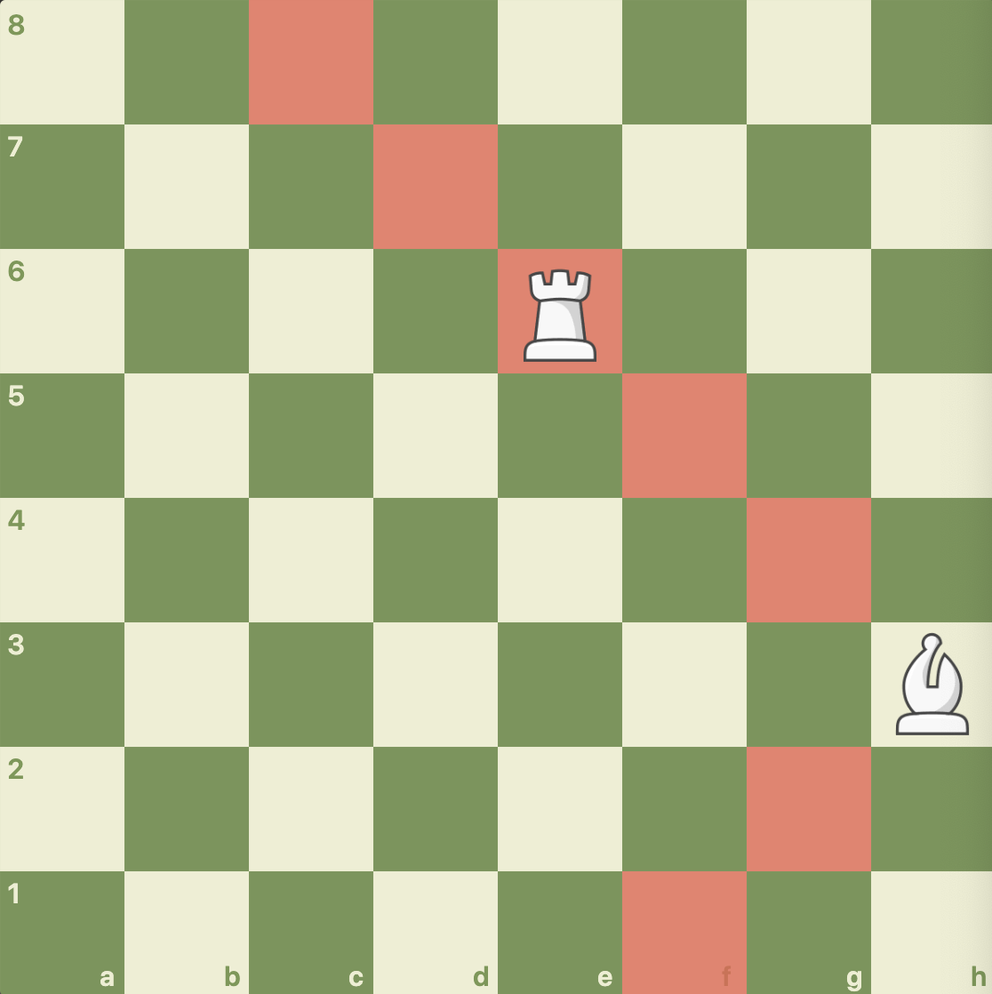

The red highlighted squares below should return true for checkEmptyDiagonalMove ():

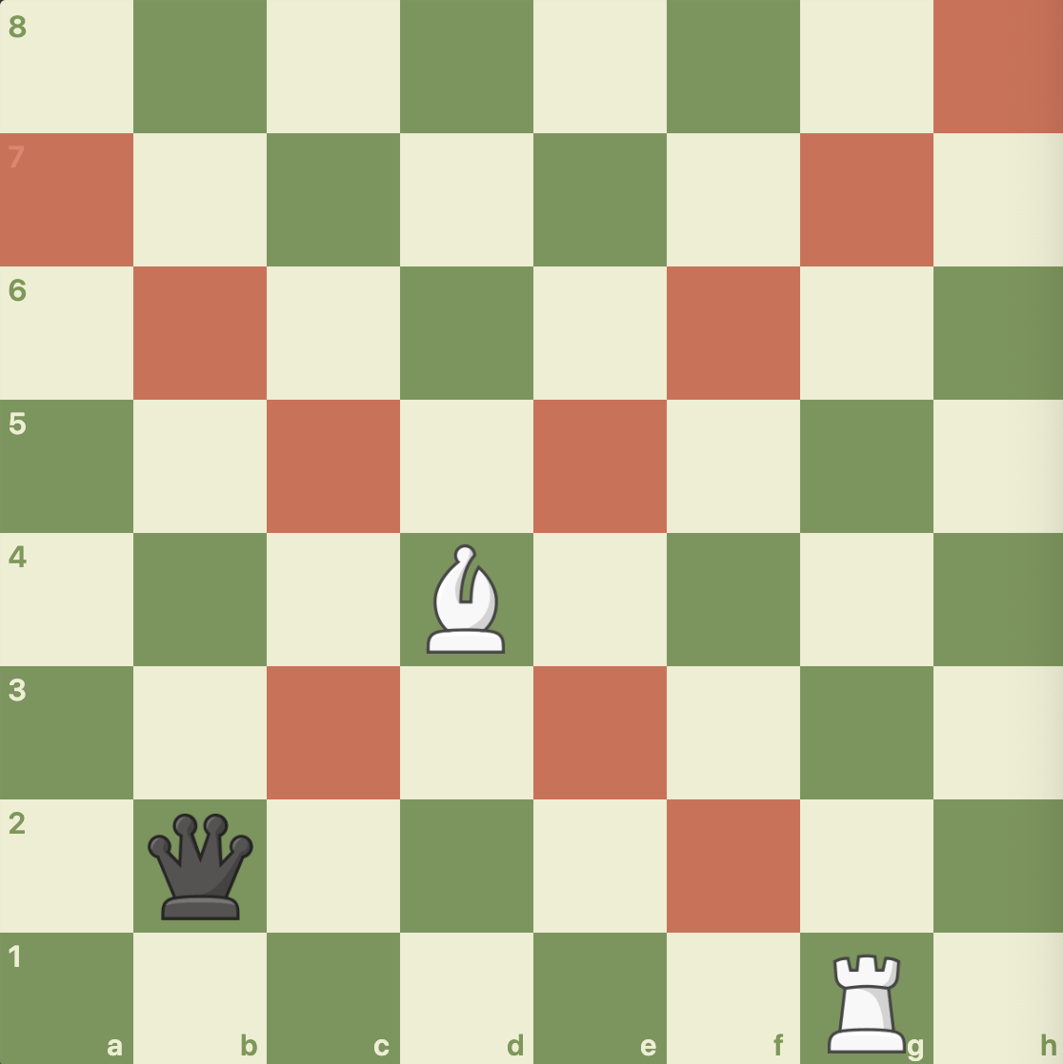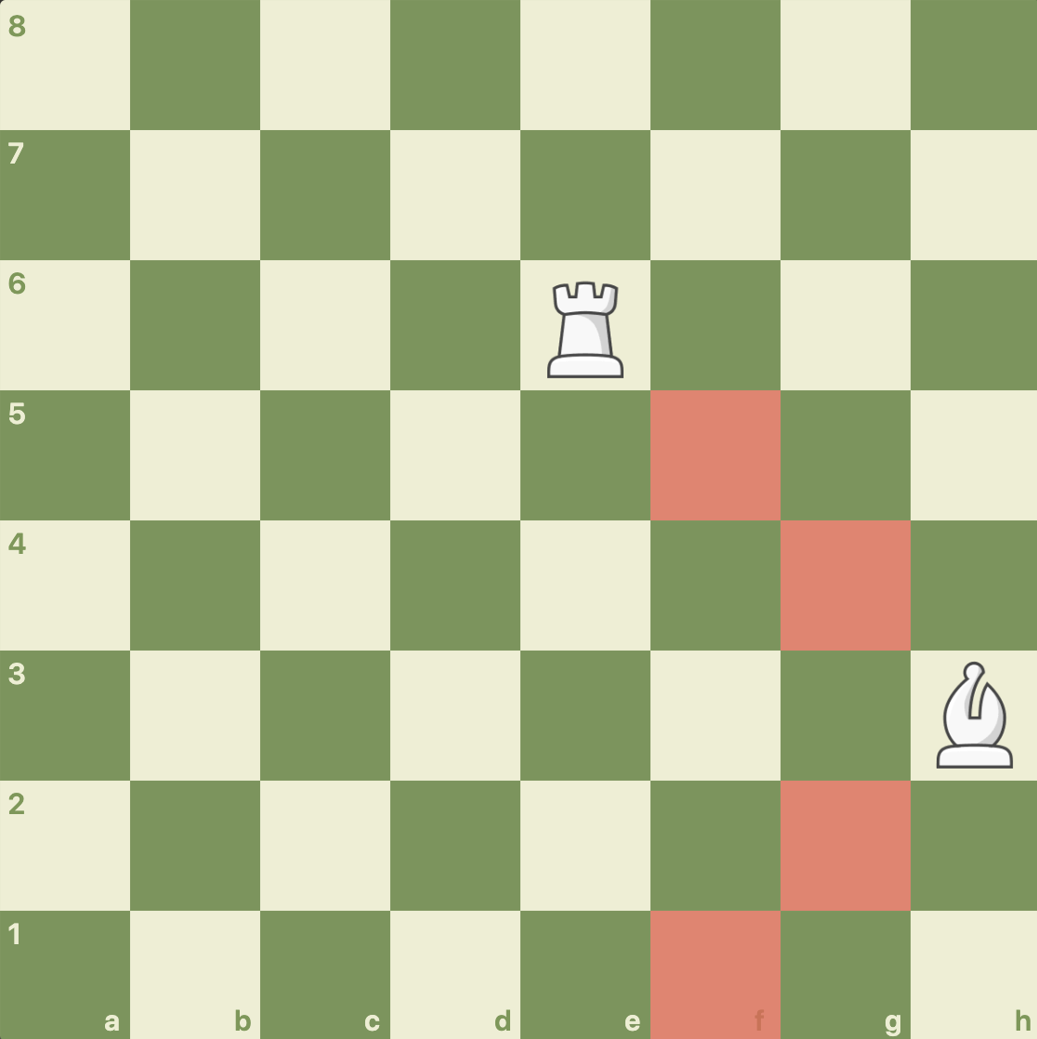

The test is grouped under testCheckEmptyDiagonalMove() in ChessTester.java::307-346. The test passed successfully.

DiagonalMove::isValidDiagonalNonCaptureMove() and DiagonalMove::isValidDiagonalCaptureMove()

For the second test, I will be testing the DiagonalMove methods which checks if a diagonal move (capture or noncapture) can be made at that location. I will do this by making a BishopPiece in the center of the board and one on the side of the board in the 2 boards mentioned above, with the exception that in the 2nd board, I will substitute the white rook for a black one to check to see if the bishop can capture other side’s pieces. However, instead of just checking diagonal squares, I will check all squares, including 1 square out of bounds, because these methods check to make sure they are diagonal squares. The red highlighted squares below should return true for isValidDiagonalNonCaptureMove():

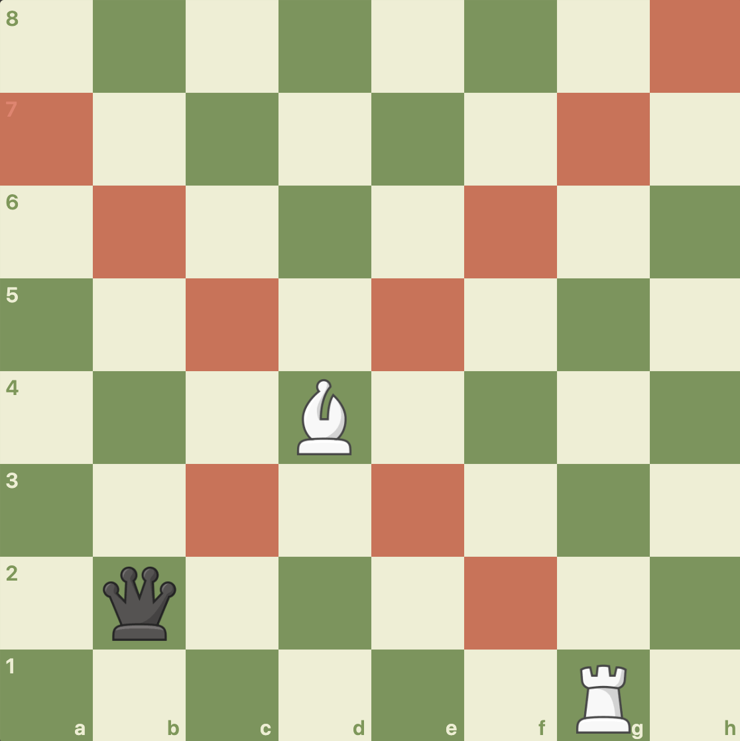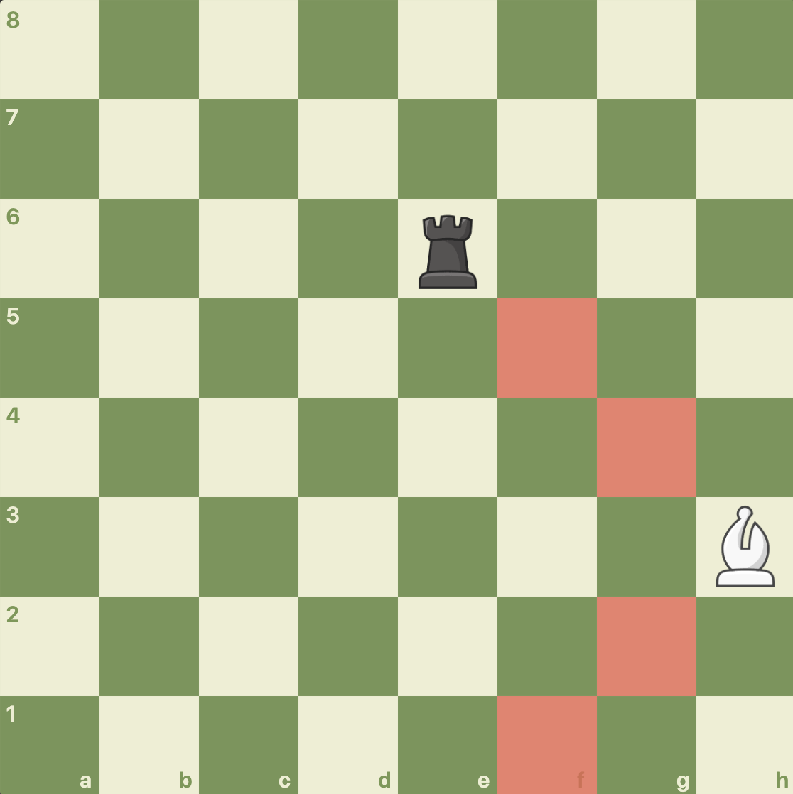

The red highlighted squares below should return true for isValidDiagonalCaptureMove():

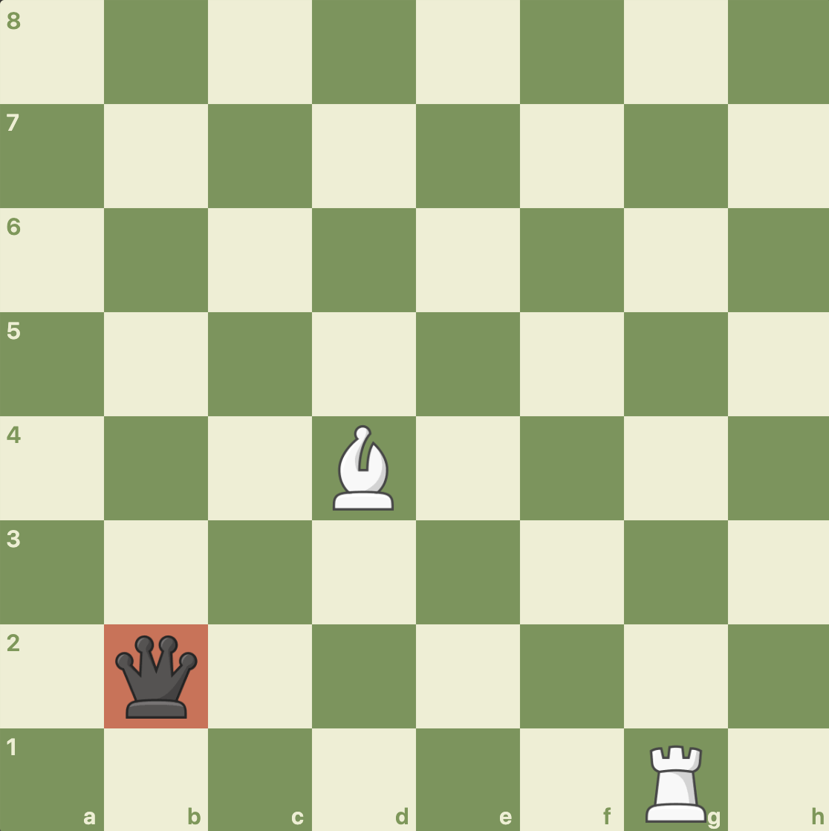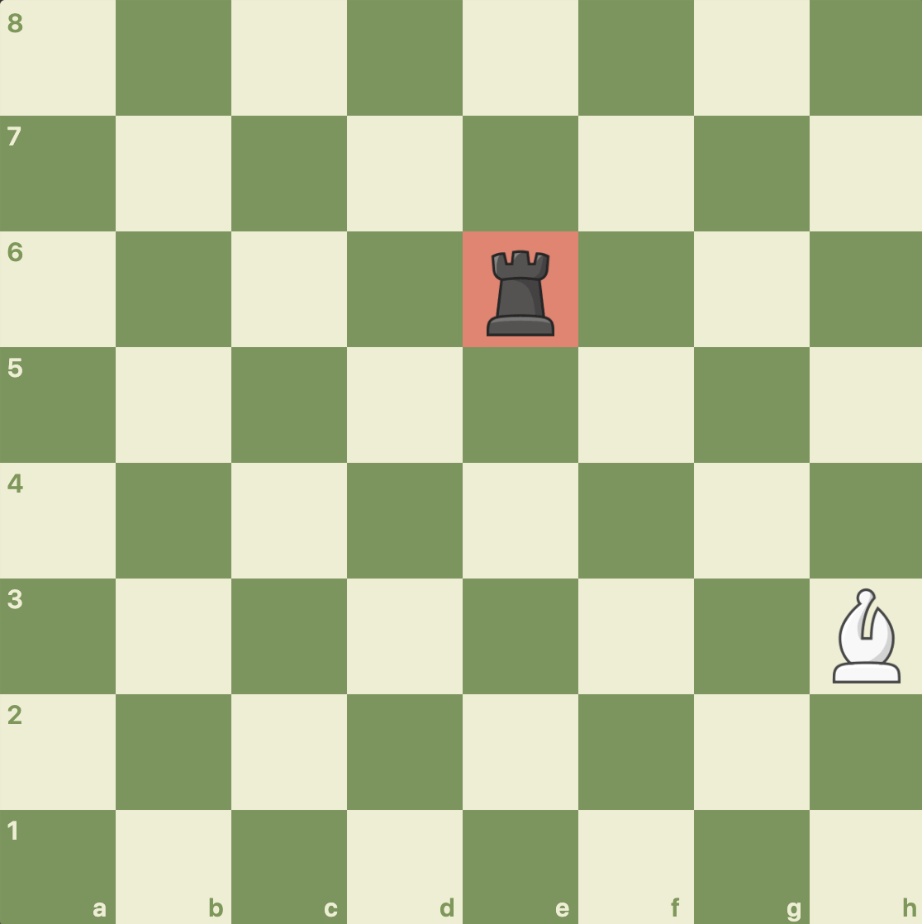

The test is grouped under testDiagonalMove() in ChessTester.java::353-406. The test passed successfully.

BishopPiece::isLegalNonCaptureMove(), and BishopPiece::isLegalCaptureMove()

For the third test, I will test the 2 positions mentioned above in the 2nd test. I will do this by using a BishopPiece to test the isLegalMove(). I am not testing BishopPiece’s isLegalNonCaptureMove() and isLegalCaptureMove() separately because they are basically a repeat of DiagonalMove’s methods. For the 2 positions, the red highlighted squares below should return true for isLegalMove():

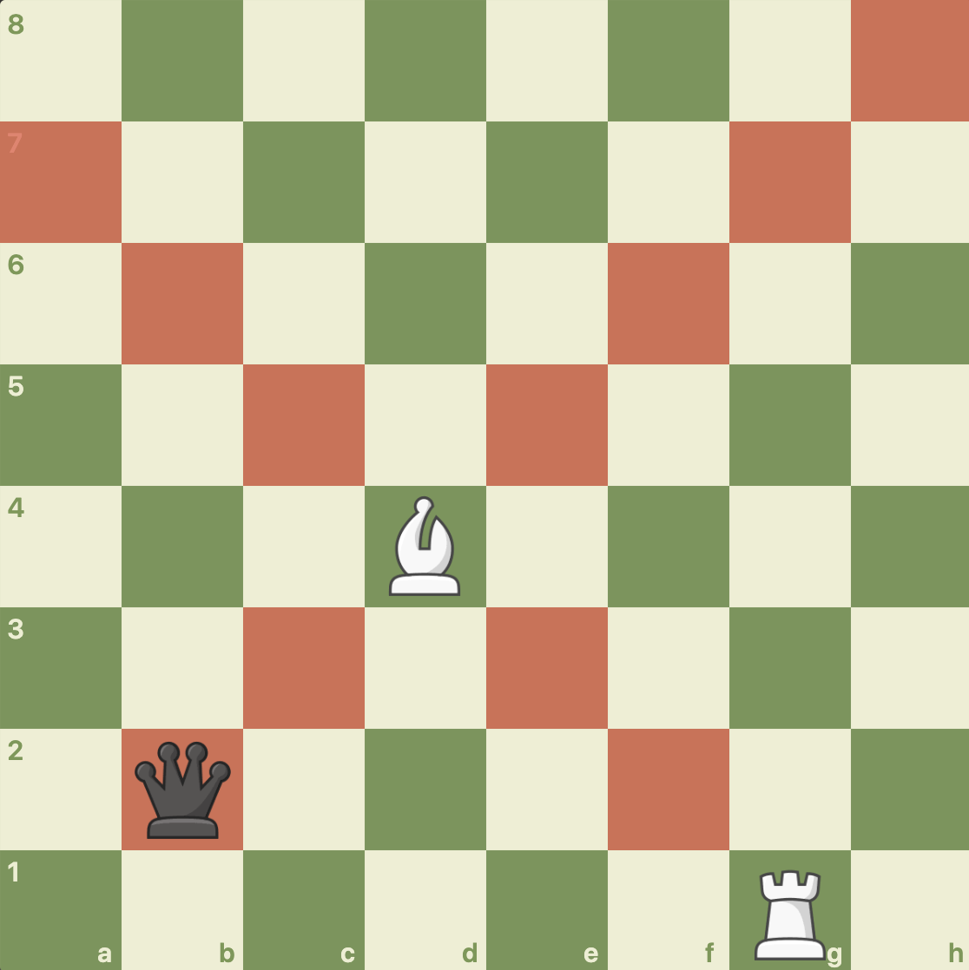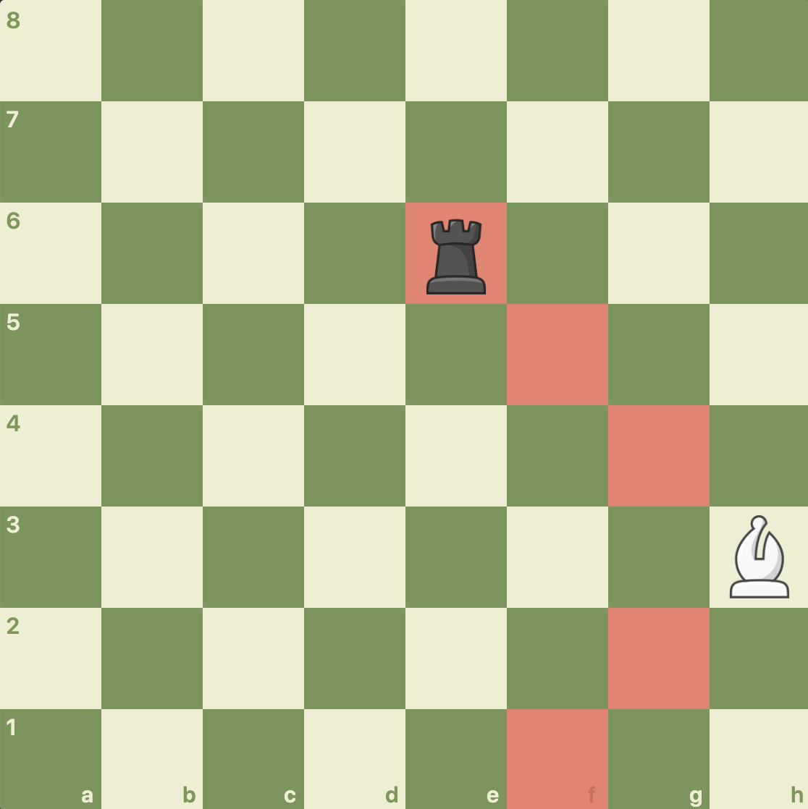

The test is grouped under testBishopPieceIsLegalMove() in ChessTester.java::413-452. The test passed successfully.

RookPiece and StraightMove

## Introduction

This will cover all methods of the RookPiece. In addition, StraightMove is fundamentally important to RookPiece, so for RookPiece’s methods isLegalNonCaptureMove(int row, int column) and isLegalCaptureMove(int row, int column), I will first test StraightMove’s respective methods and then test RookPiece’s methods.

StraightMove::checkEmptyStraightMove()

For the first test, I will be testing the checkEmptyStraightMove() method which should return true if all of the moves up to the current square (including the current square) is empty. I will test 2 positions with only the red highlighted squares, listed below. This is because this method checks for empty squares between the squares but doesn’t actually check if the square passed into the function is a valid vertical/horizontal move or not. That is done by isValidStraightCaptureMove() and isValidStraightNonCaptureMove().

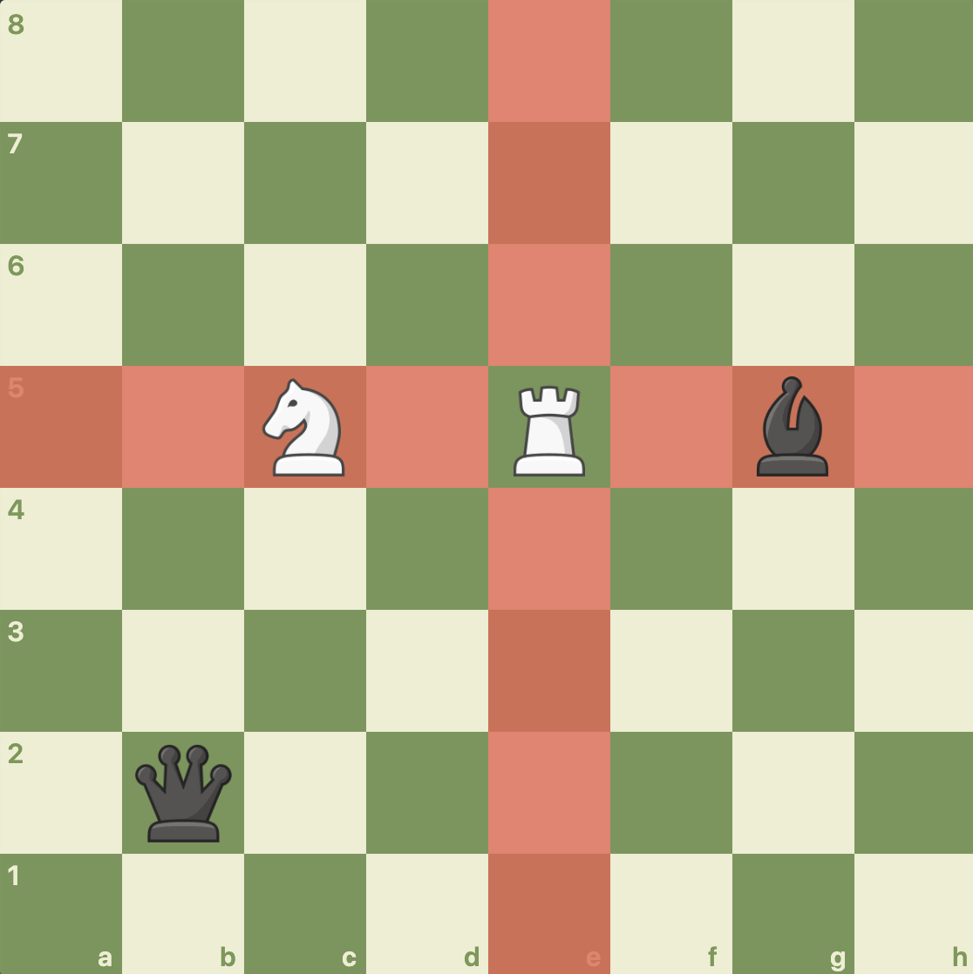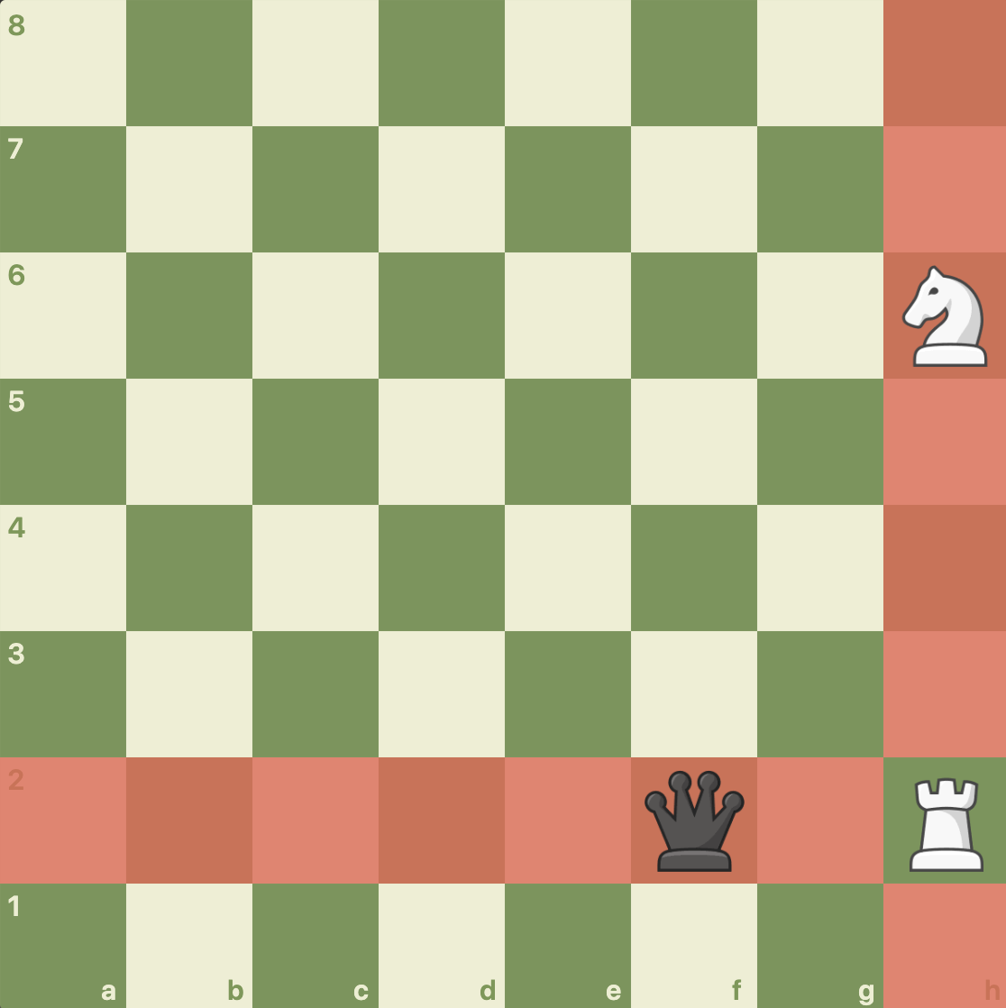

The red highlighted squares below should return true for checkEmptyStraightMove():

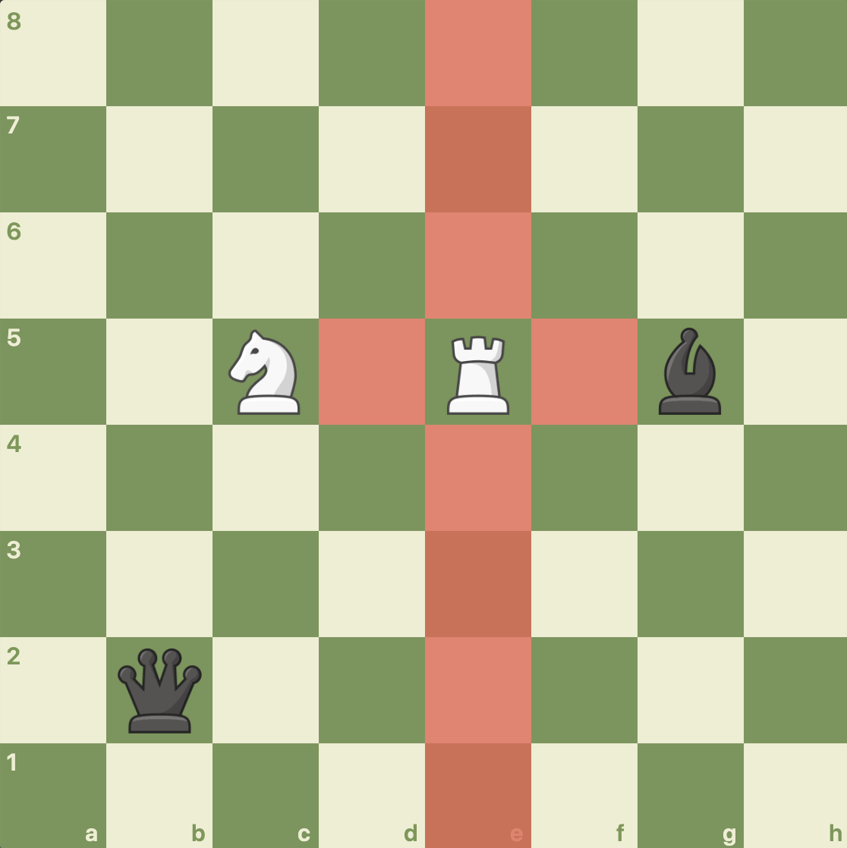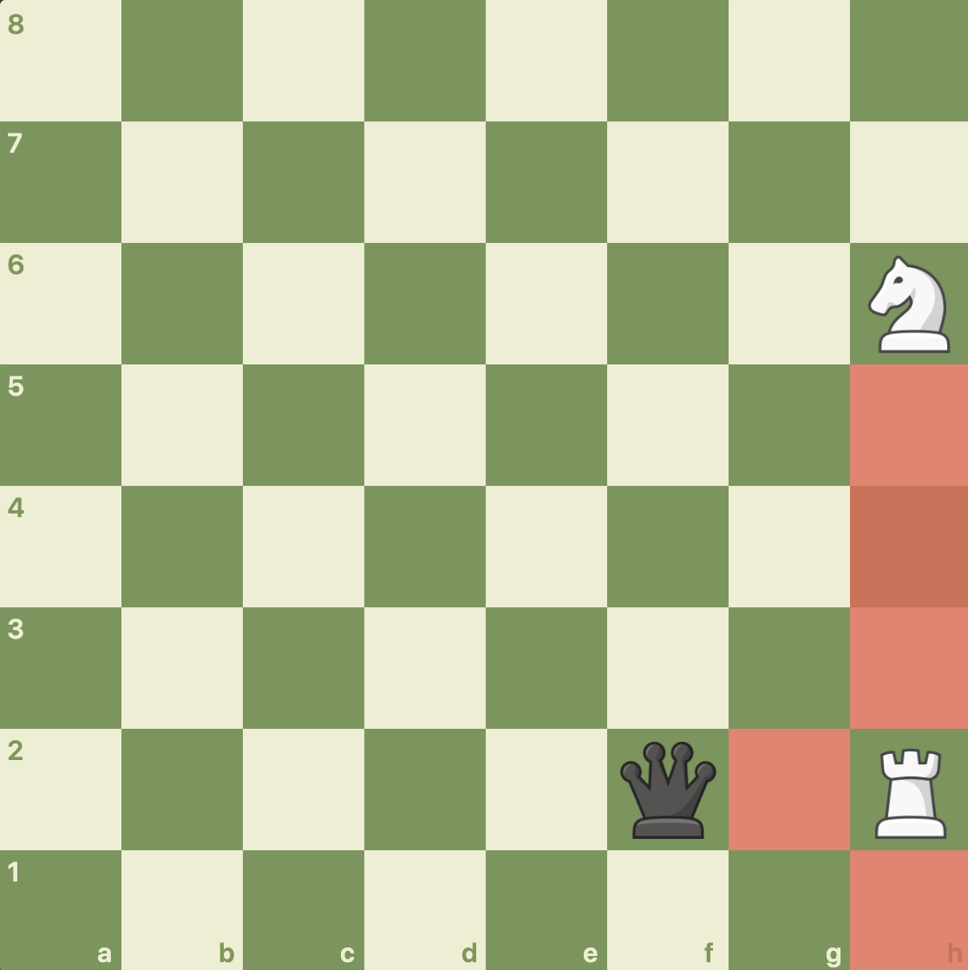

The test is grouped under testCheckEmptyStraightMove() in ChessTester.java::459-529. The test passed successfully.

StraightMove::isValidStraightNonCaptureMove() and StraightMove::isValidStraightCaptureMove()

For the second test, I will be testing the StraightMove methods which checks if a straight move (capture or noncapture) can be made at that location. I will do this by making a RookPiece in the center of the board and one on the side of the board, as shown above. However, instead of just checking straight squares, I will check all squares, including 1 square out of bounds, because these methods check to make sure they are straight squares. The red highlighted squares below should return true for isValidStraightNonCaptureMove():



The red highlighted squares below should return true for isValidStraightCaptureMove():

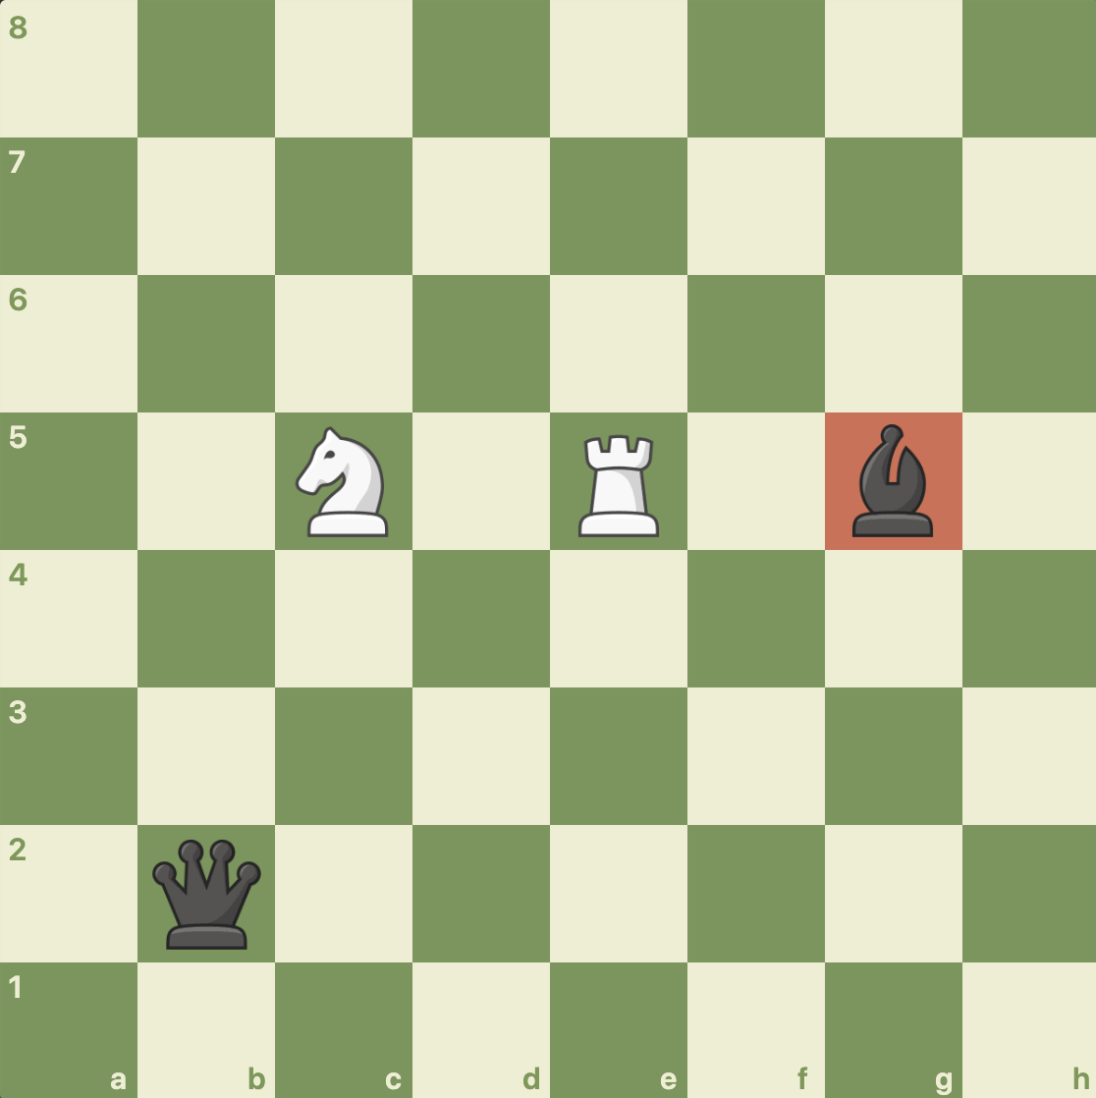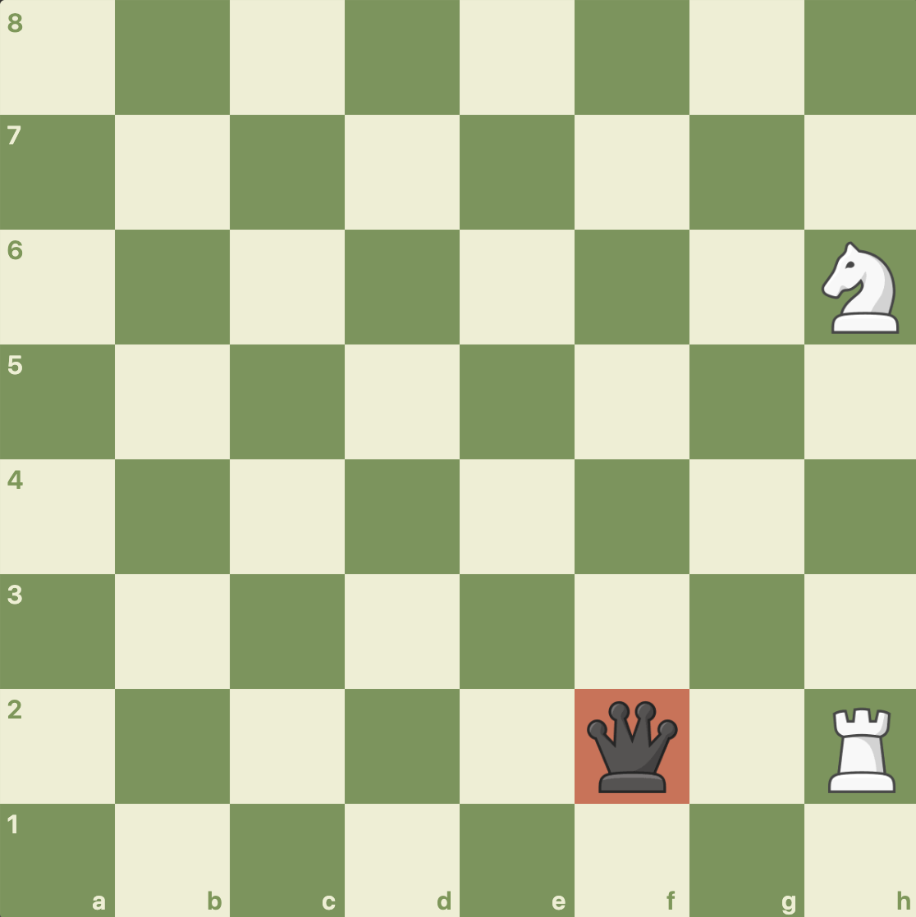

The test is grouped under testStraightMove() in ChessTester.java::536-591. The test passed successfully.

RookPiece::isLegalNonCaptureMove() and RookPiece::isLegalCaptureMove()

For the third test, I will test the 2 positions mentioned above in the 2nd test. I will do this by using a RookPiece to test the isLegalMove(). I am not testing RookPiece’s isLegalNonCaptureMove() and isLegalCaptureMove() separately because they are basically a repeat of StraightMove’s methods. For the 2 positions, the red highlighted squares below should return true for isLegalMove():

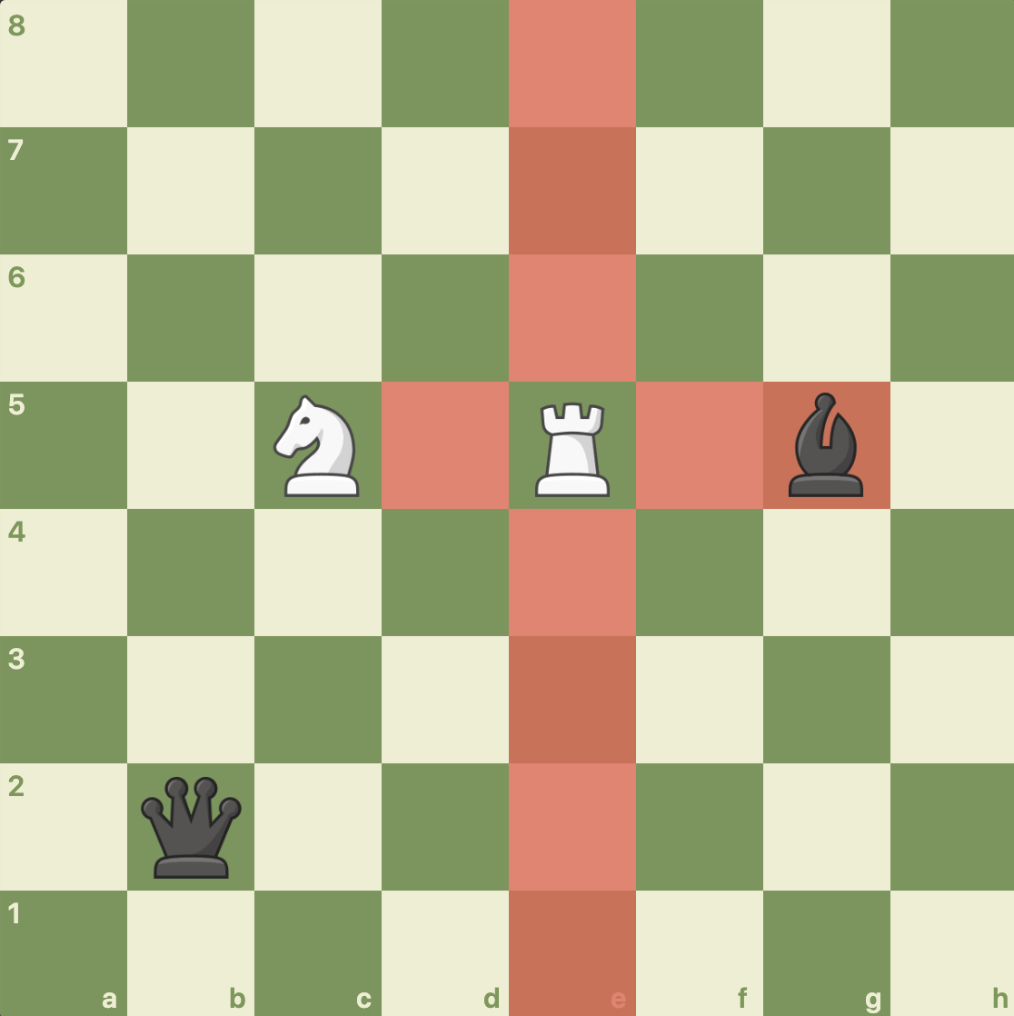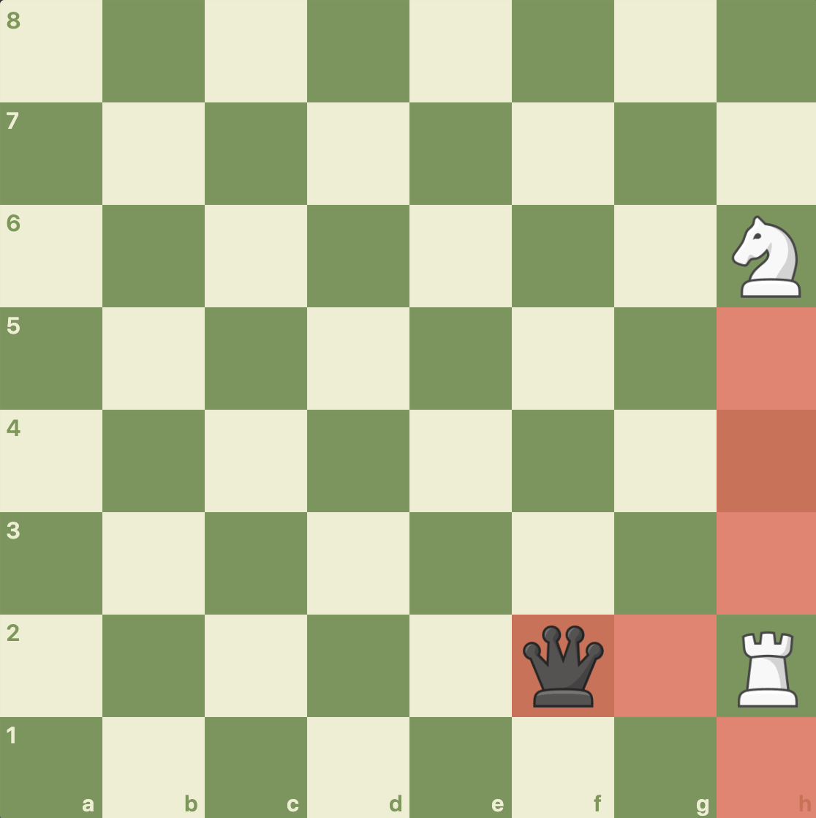

The test is grouped under testRookPieceIsLegal() in ChessTester.java::598-639. The test passed successfully.

QueenPiece

## Introduction

This will cover all methods of the QueenPiece. Since both StraightMove and DiagonalMove were covered in previous sections, I will only test RookPiece’s isLegalNonCaptureMove() and isLegalCaptureMove() methods.

QueenPiece::isLegalNonCaptureMove(), and QueenPiece::isLegalCaptureMove()

For the first test, I will test the 2 positions mentioned below in the 2nd test. I will do this by using a QueenPiece to test QueenPiece’s isLegalNonCaptureMove() and isLegalCaptureMove() separately.

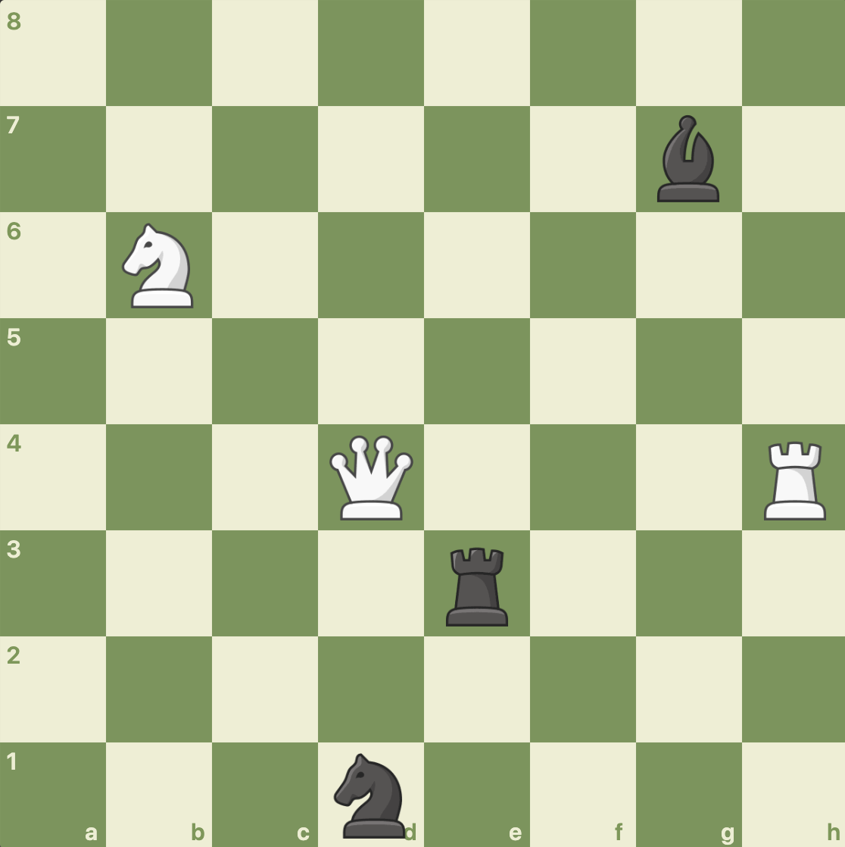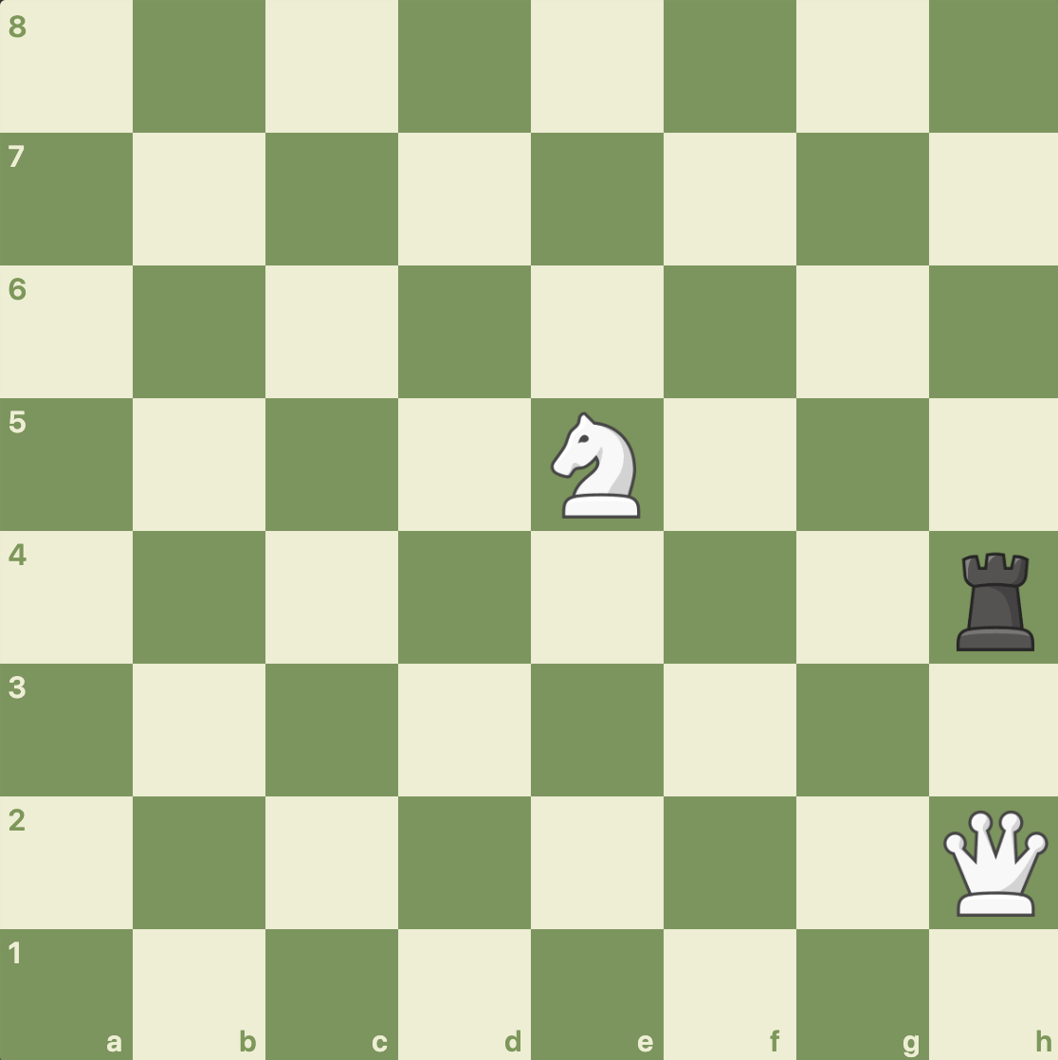

The red highlighted squares below should return true for isLegalNonCaptureMove():

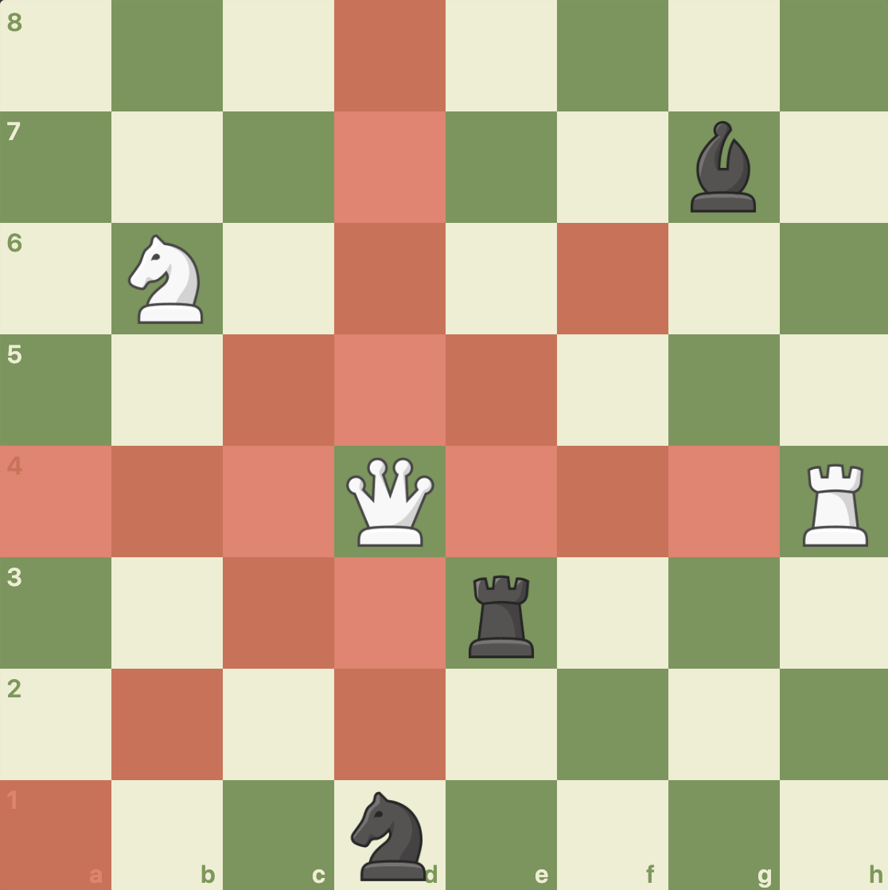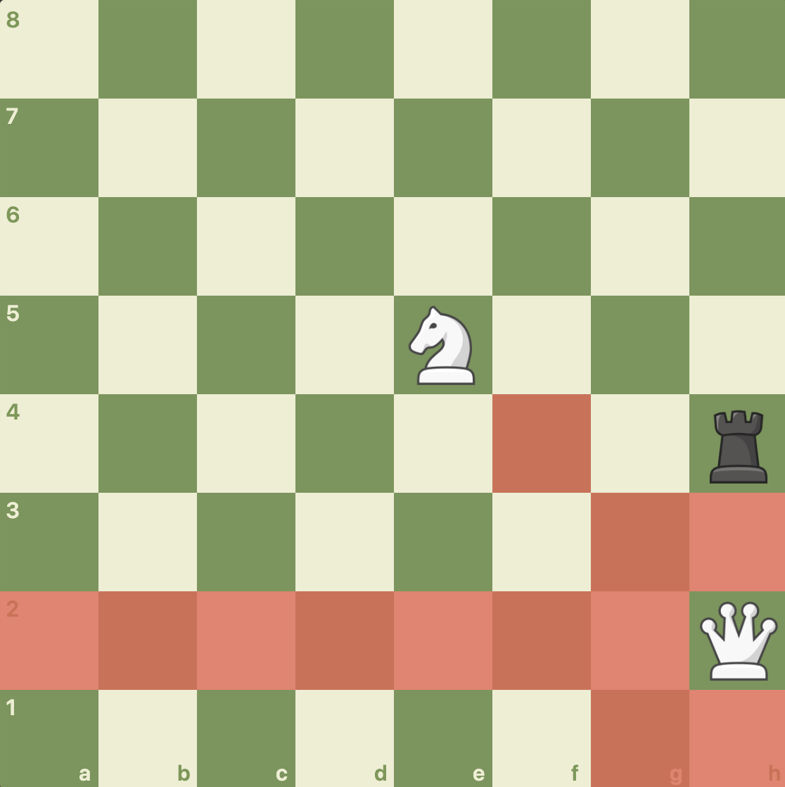

The red highlighted squares below should return true for isLegalCaptureMove():

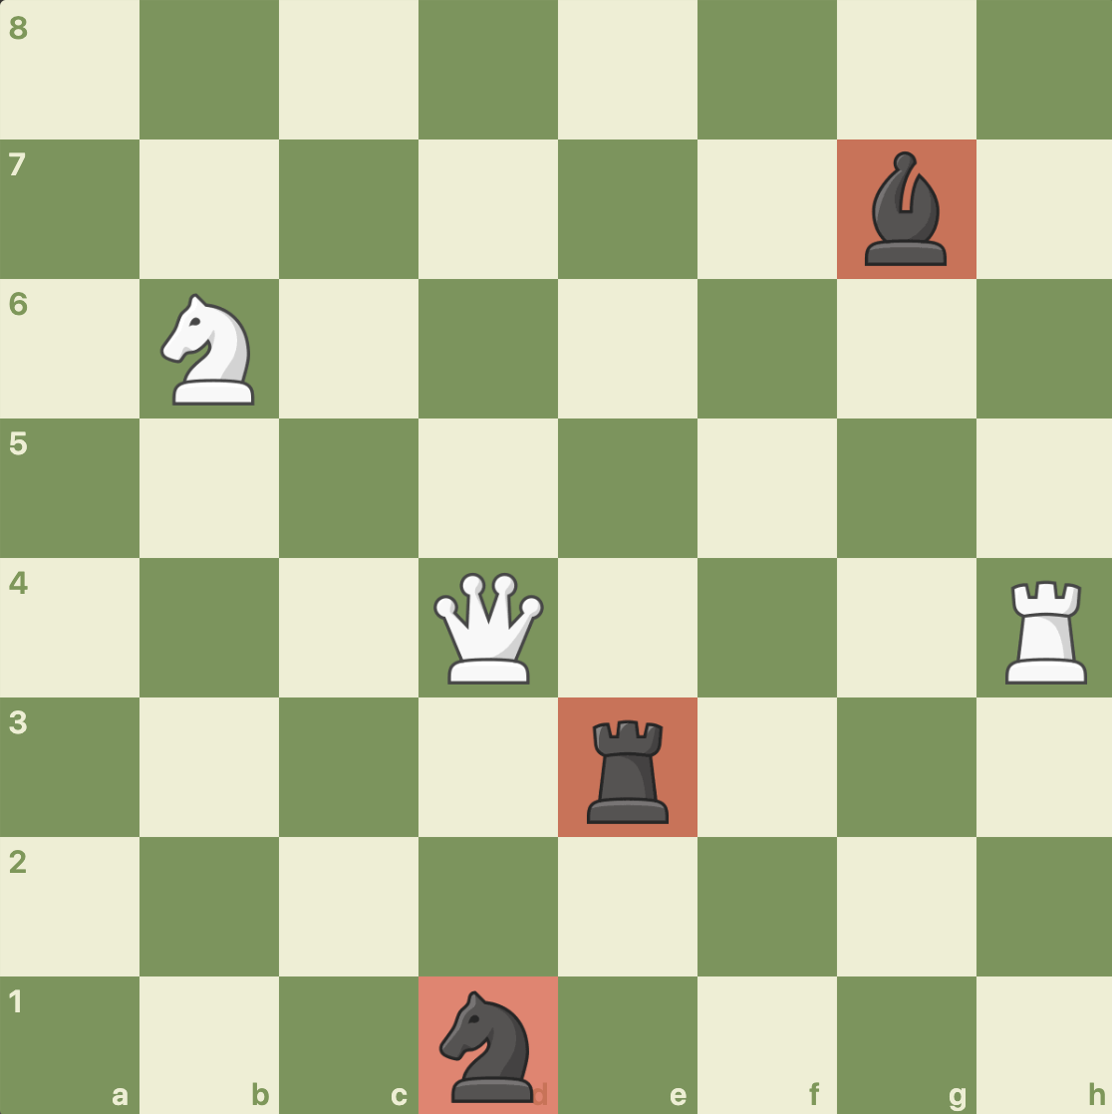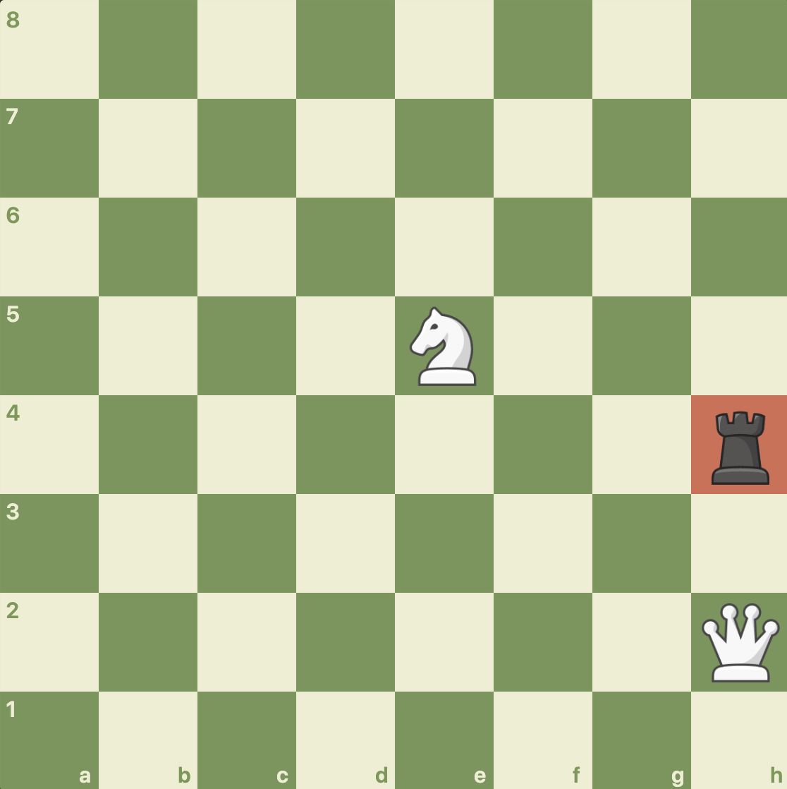

The test is grouped under testQueenPieceIsLegal() in ChessTester.java::646-703. The test passed successfully.

KingPiece, KingMove, and CastlingMove

## Introduction

This will cover all methods of the KingPiece. In addition, KingMove is fundamentally important to KingPiece, so for KingPiece’s methods isLegalNonCaptureMove(int row, int column) and isLegalCaptureMove(int row, int column), I will first test KingMove’s respective methods and then test KingPiece’s methods. In addition, CastlingMove will also need to be tested, specifically to make sure that (1) castling cannot take place if either of the pieces have been moved, (2) castling cannot take place if either the rook or the king have been moved, and (3) castling cannot take place if pieces are in the way. This will also need be checked in all 4 directions. KingPiece also contains methods regarding checks that also need to be checked.

CastlingMove::isValidCastlingMove()

For the first test, I will be testing CastlingMove. CastlingMove is perhaps the most complex. First, I will put the kings and rooks in the right spot and test the castling moves in all 4 directions. Then I will call moveDone() on the rooks which should disallow any castling. I will reset and call moveDone() on the kings which should disallow any castling as well. Then, I will put pieces blocking the way of the castling, which should disallow any castling. Finally, I will put pieces that threaten squares between the moves, which should also disallow castling. All of this will be done in all 4 directions. Castling also can’t occur when the king is in check, but this is not checked by this interface and thus will not be checked during this part of the project.

So first, we will check castling moves for each direction, starting with West and East and then doing North and South. Below is the layout of this test, as well as the red highlighted squares indicating which moves should be allowed. This will be done by checking every square, including squares that are outside the bounds of the chess board.

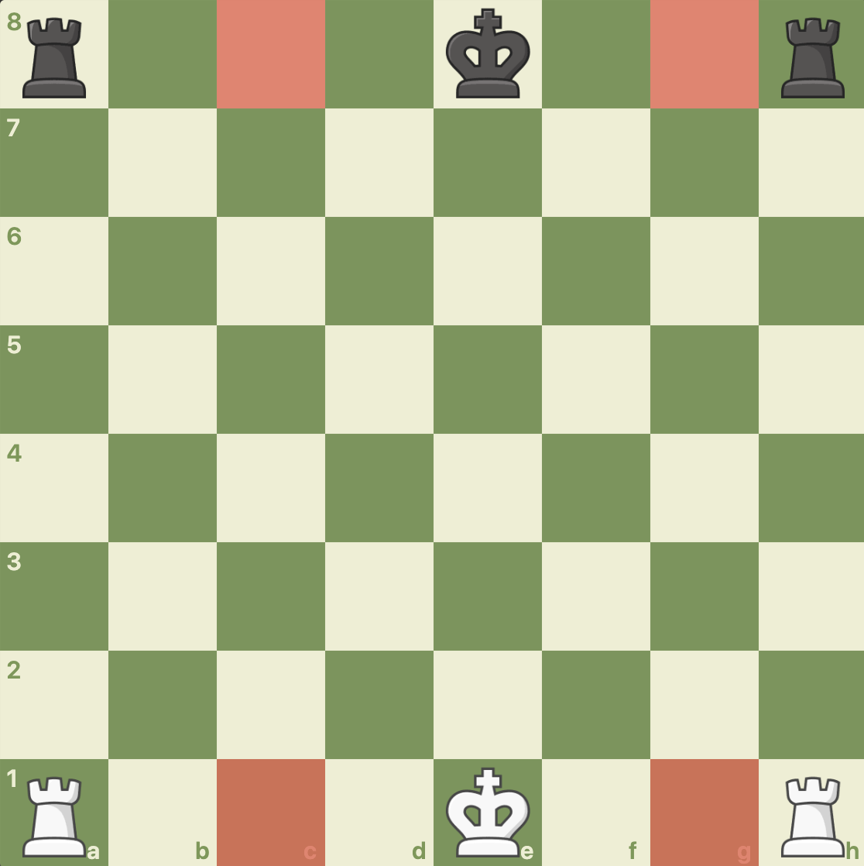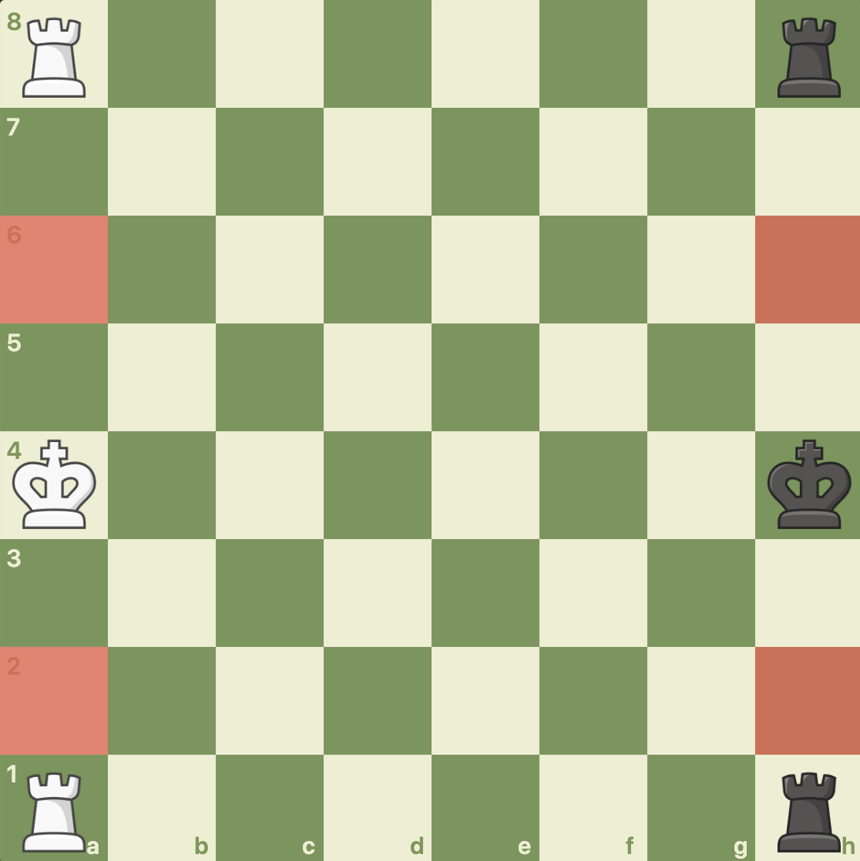

Next, I will call moveDone() on one of the rooks (kingside for white, queenside for black). The resulting valid moves will be shown below. For white, the only valid move should be queenside, and for black, the only valid move should be kingside.

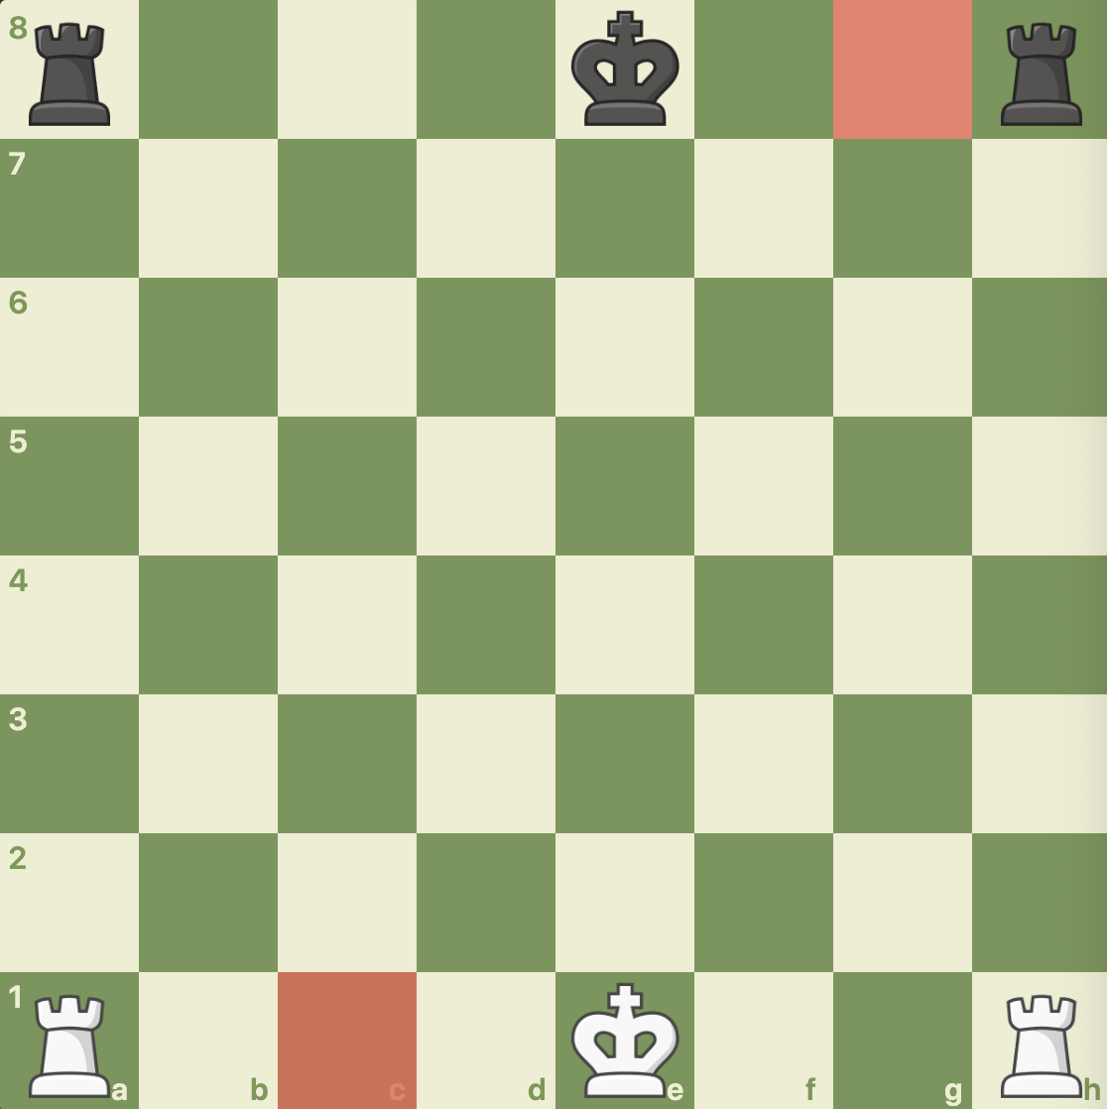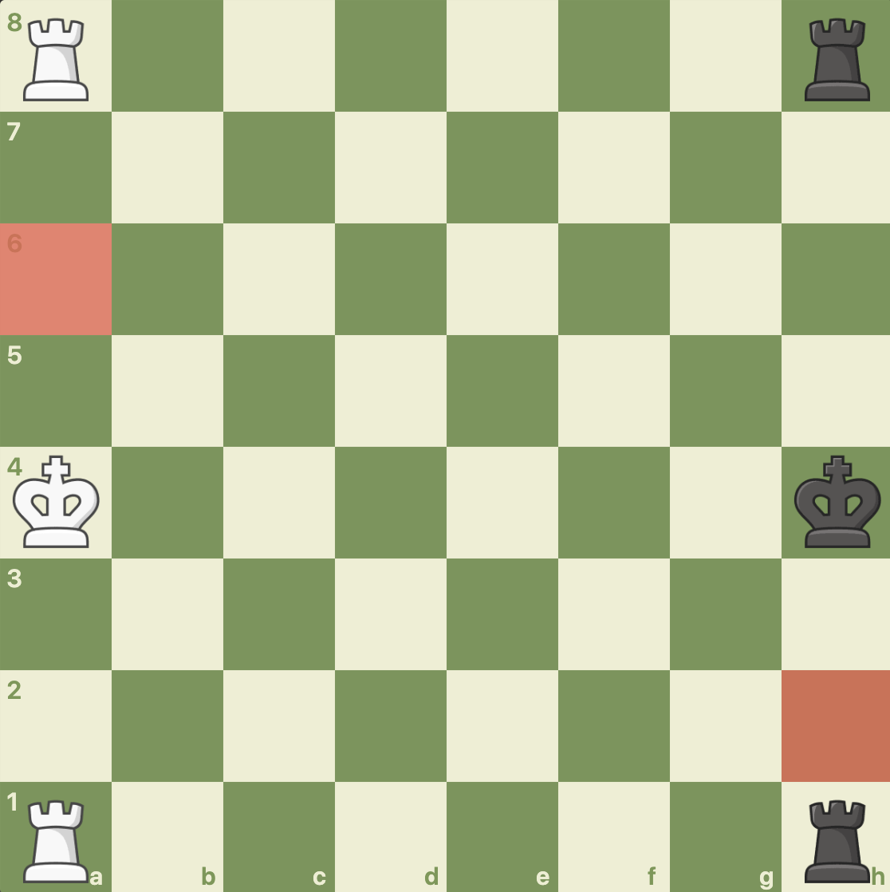

Next, I will reset the rooks so they will castle again but this time I will call moveDone() on the kings. Both castling moves should be illegal and no valid castling moves are available for either side.

Finally, I will place reset the kings and place a queen in the following positions so that only that the white king/black king cannot castle. They cannot castle one way because they’re being blocked by the piece, and they cannot castle the other way because one of the squares are being threatened by the queen. The below shows these 2 positions.

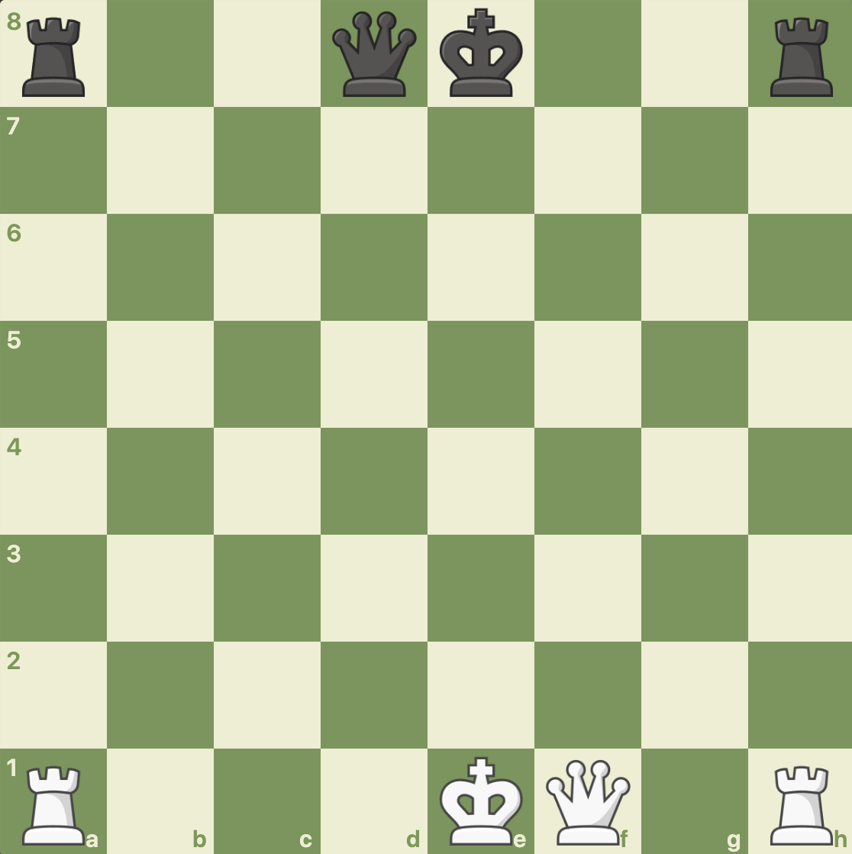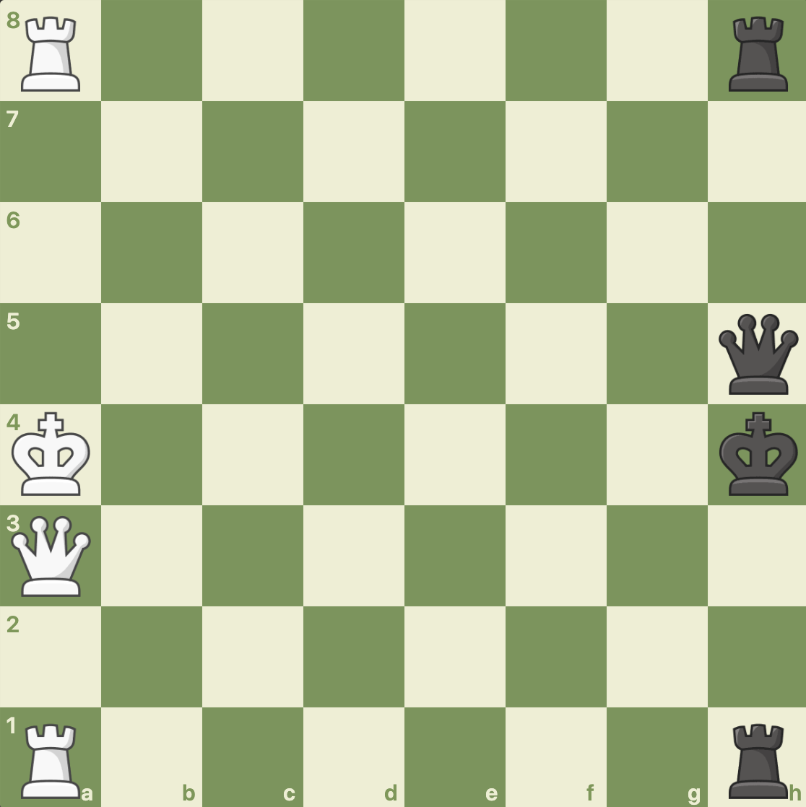

The test is grouped under testCastlingMove() in ChessTester.java::710-950. The test passed successfully.

KingMove::isValidKingNonCaptureMove() and KingMove::isValidKingCaptureMove()

For the second test, I will be testing the KingMove methods which checks if a single king move (capture or noncapture) can be made at that location. I will do this by making a KingPiece in the center of the board and one on the side of the board, as shown below. I will check all squares, including 1 square out of bounds, because these methods check to make sure they are straight squares. Note that this move does not check if the move puts the KingPiece in check, as that is done in the EuropeanChess class.

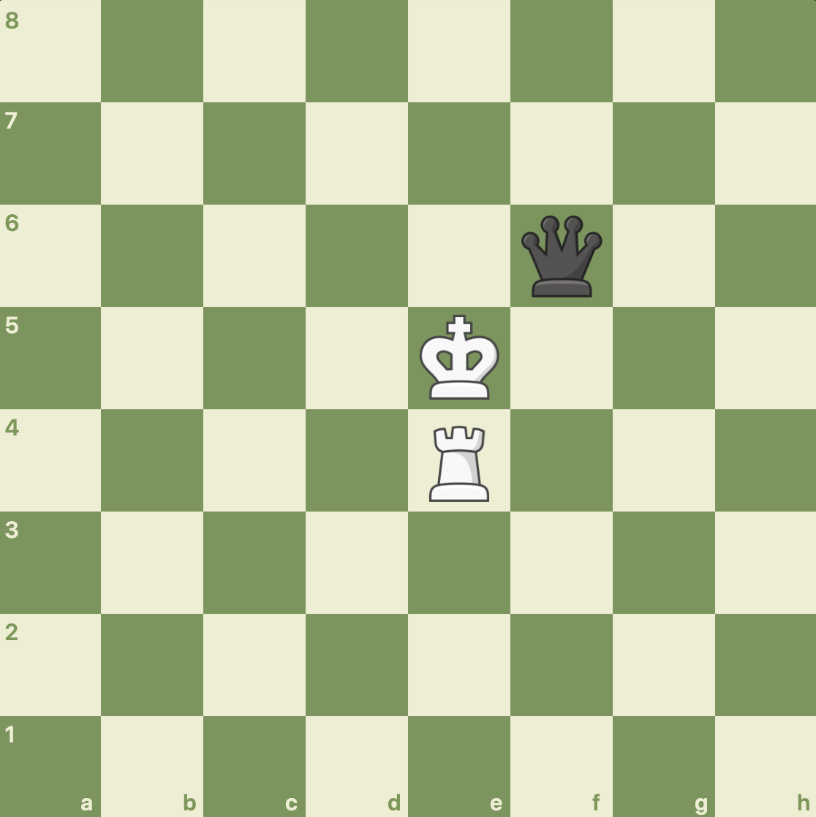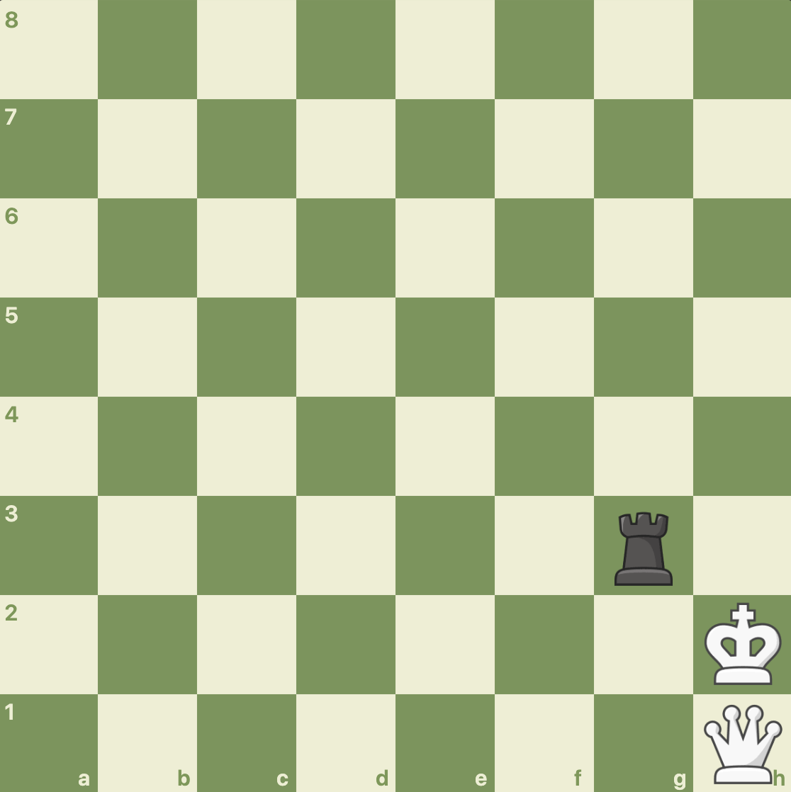

The red highlighted squares below should return true for isValidKingNonCaptureMove():

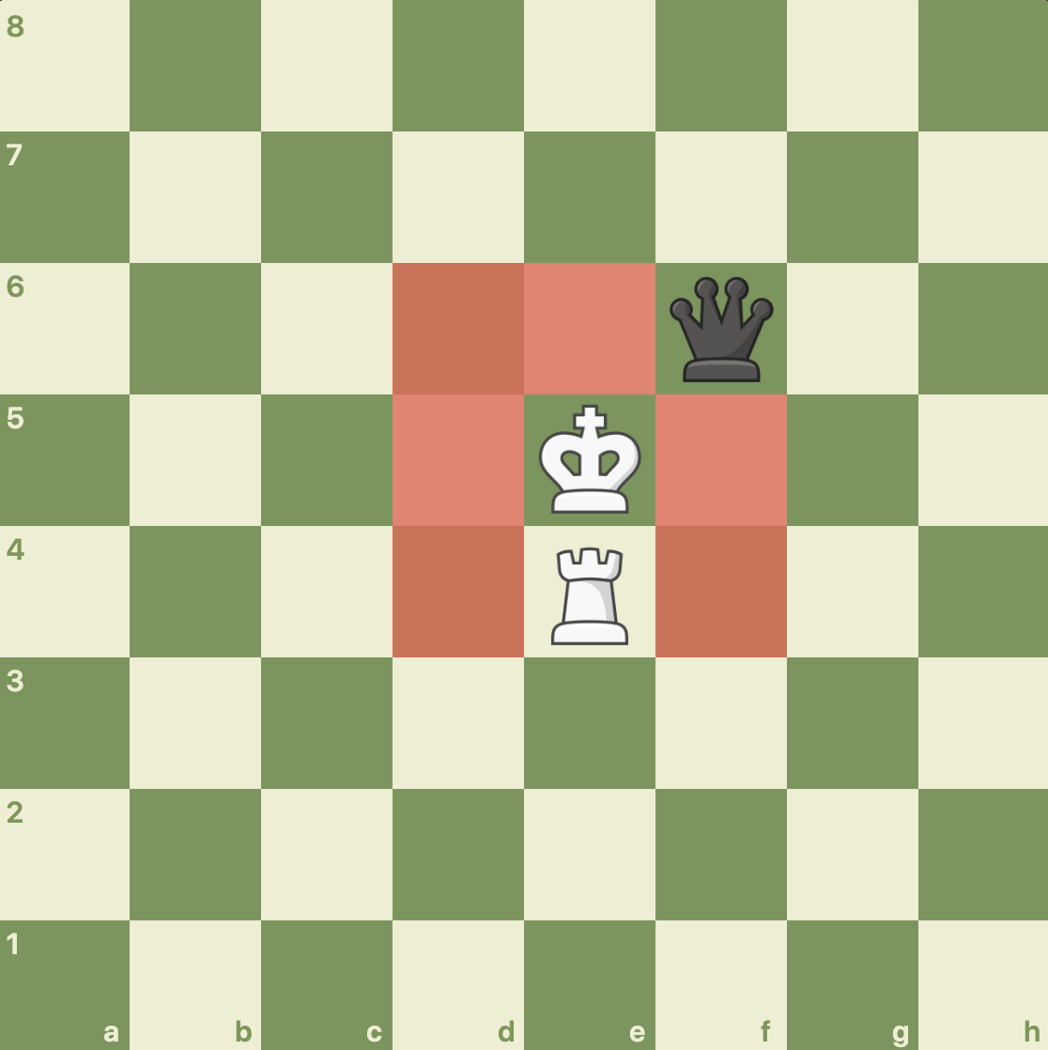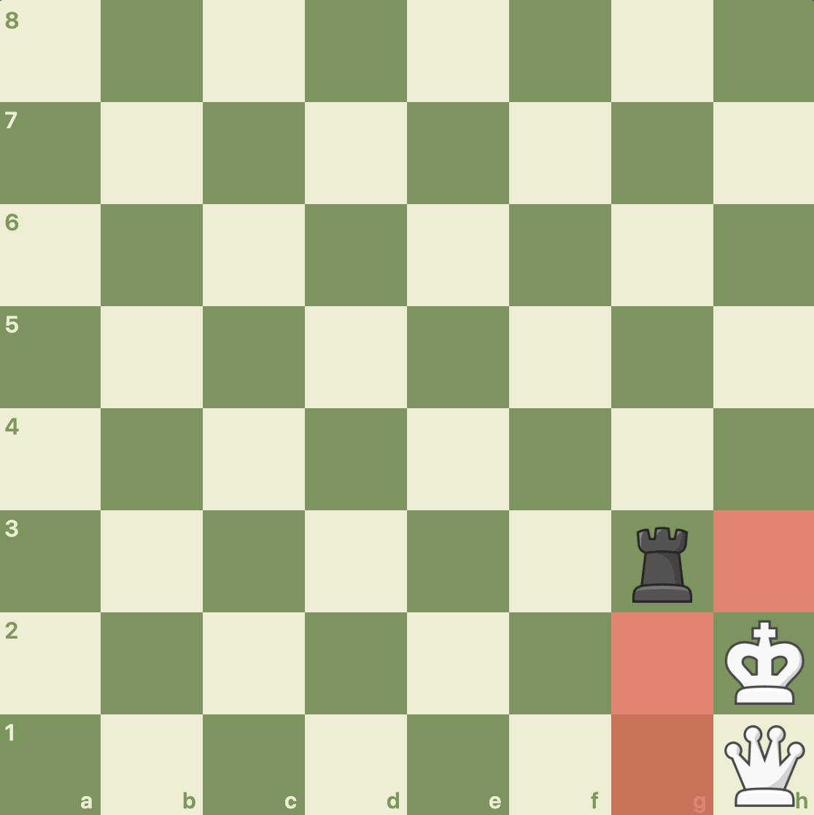

The red highlighted squares below should return true for isValidKingCaptureMove():

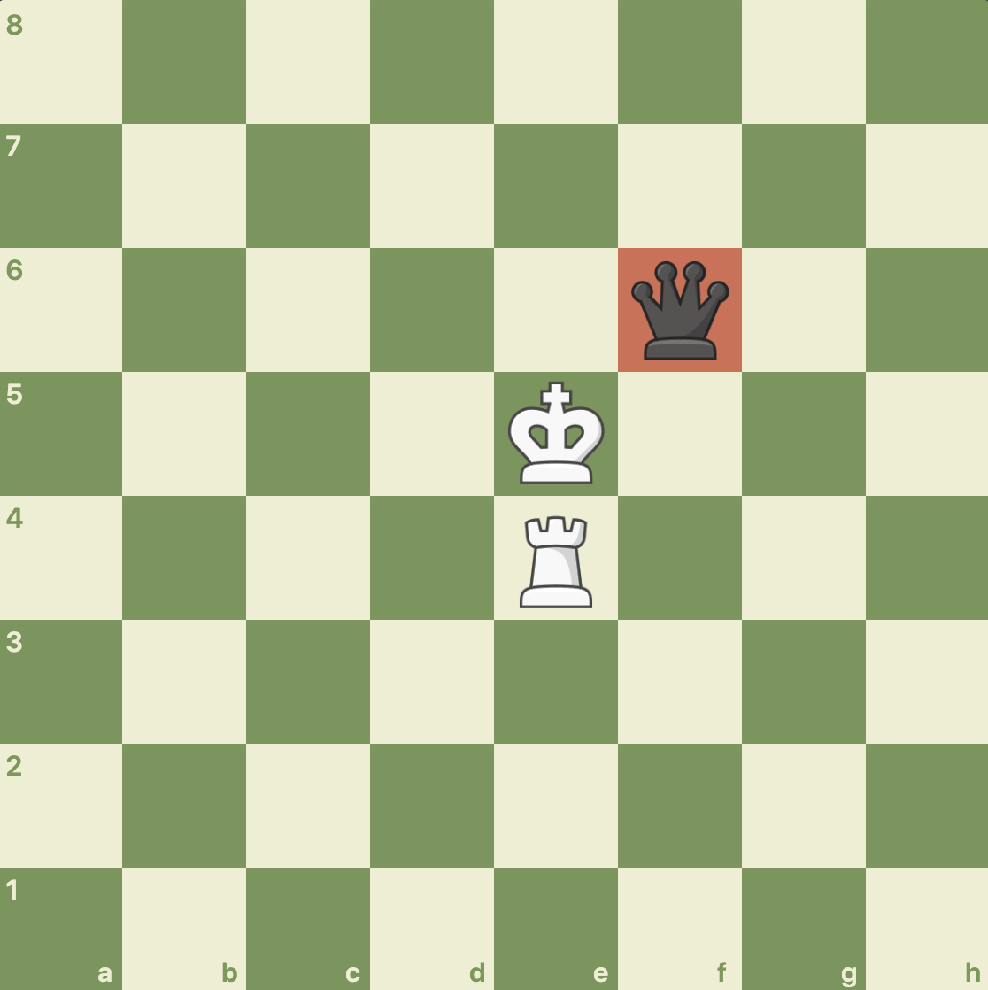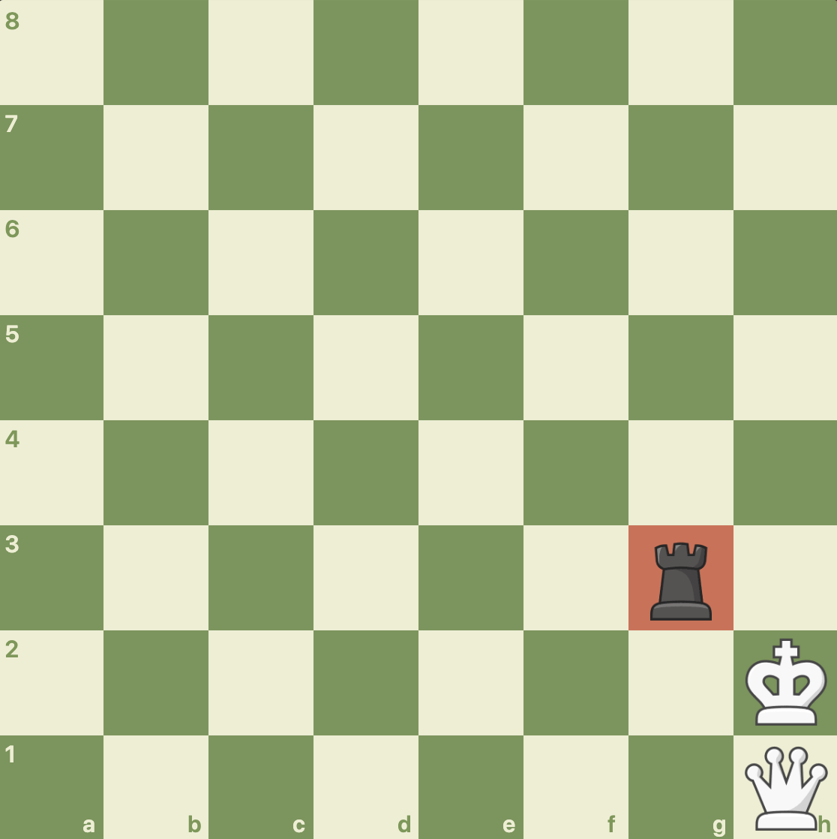

The test is grouped under testKingMove() in ChessTester.java::957-1011. The test passed successfully.

KingMove::isInCheck()

For the third test, I will be testing if the KingPiece can be detected to be in check or not. I will test several 3 scenarios: when the KingPiece is not in check, when it is in check, and when it is right next in front of a PawnPiece. For reasons that will become more apparent later, although a PawnPiece can move in 1 space in front if there is no piece there, it cannot capture it. As a result, we need to test that the KingPiece will not be in check if that happens. I do not need to robustly check every piece because the isInCheck() method calls the ChessBoard::squareThreatened() method which uses the isLegalMove() of each ChessPiece, so it is already being checked over there. In addition, the squareThreatened() method was modified but only to include the aforementioned pawns scenario. As a result, squareThreatened() will not be tested any further than this since it was given to us before our code. The below 3 scenarios will be used for testing:

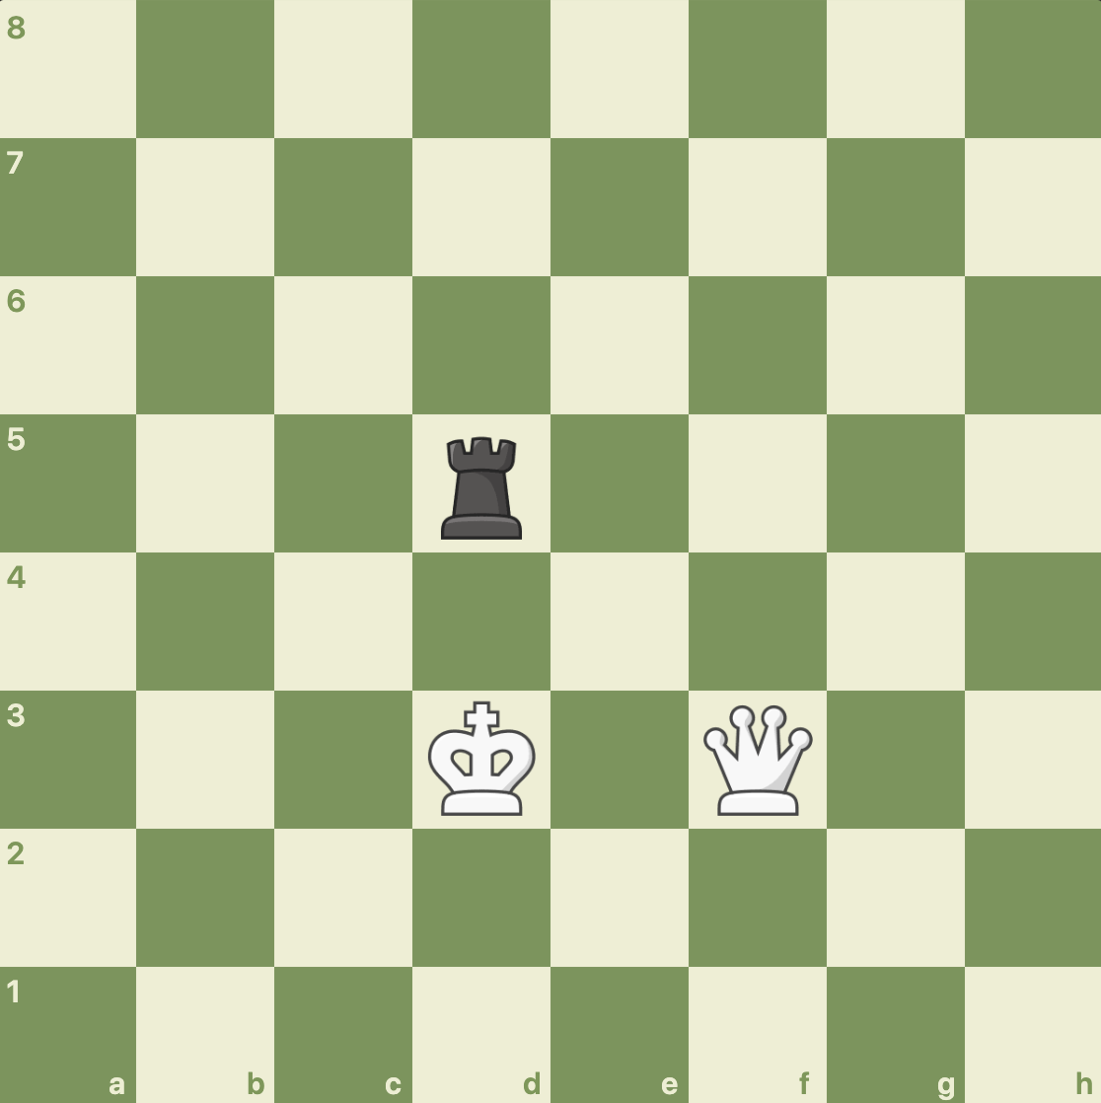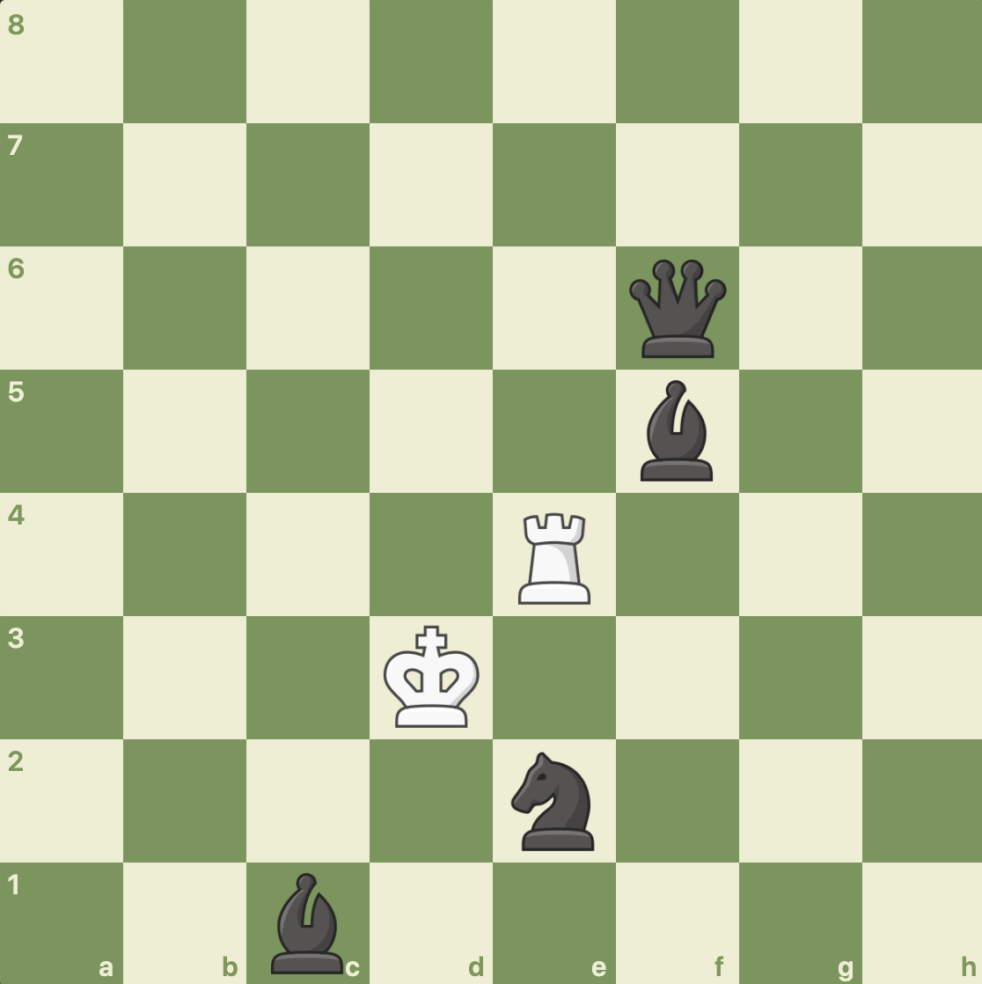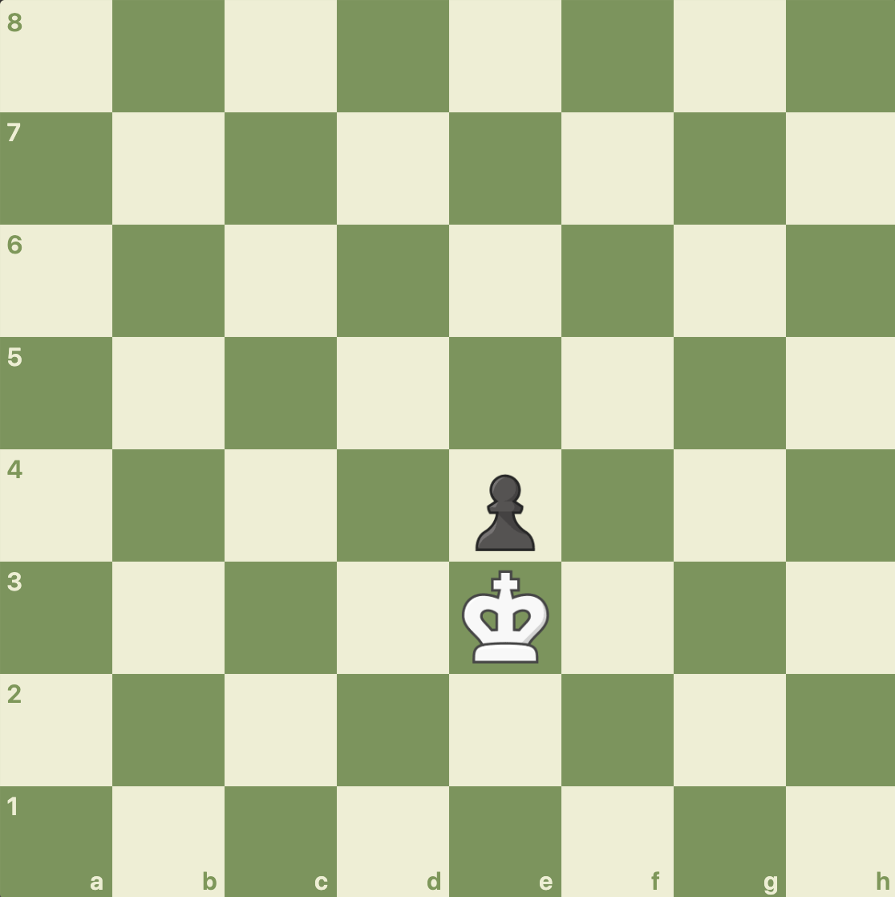

They should return false, true, and false, respectively.

The test is grouped under testIsInCheck() in ChessTester.java::1018-1047. The test passed successfully.

KingMove::getOpposingKing()

For the fourth test, I will be testing if KingPiece can find the opposite king and that KingPiece. This should never return nothing (or the default is set to location -1, -1) because in any game there is going to be 2 kings on the board. Therefore, I will only test if it can find the opposite king by putting 2 kings on the board in with pieces in the position below and calling the getOpposingKing() method of both to see if it can find the other KingPiece.

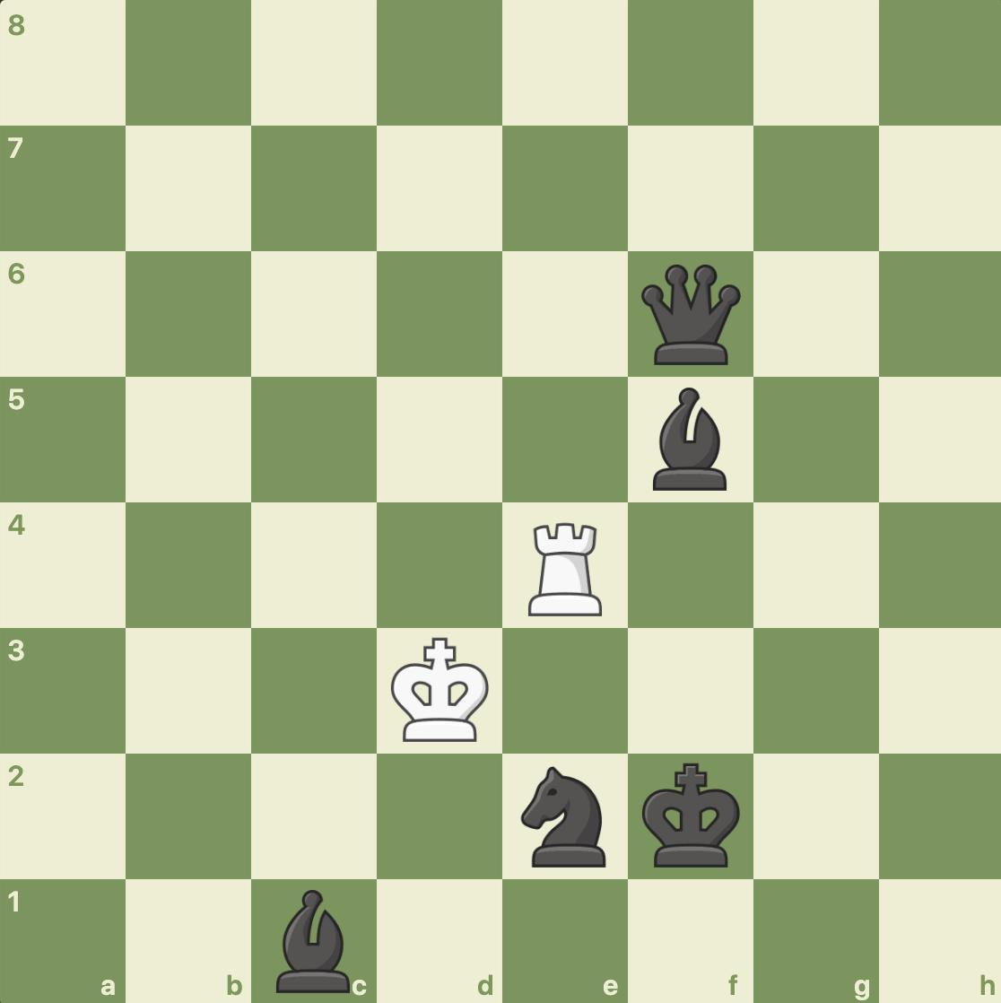

The test is grouped under testGetOpposingKing() in ChessTester.java::1054-1069. The test passed successfully.

KingPiece::isLegalNonCaptureMove(), and KingPiece::isLegalCaptureMove()

For the last and final test, I will test the 2 positions mentioned above in the 2nd test. I am not testing KingPiece’s isLegalNonCaptureMove() and isLegalCaptureMove() separately because they are basically a repeat of KingMove’s and CastlingMove’s methods. For the 2 positions, the red highlighted squares below should return true for isLegalMove():

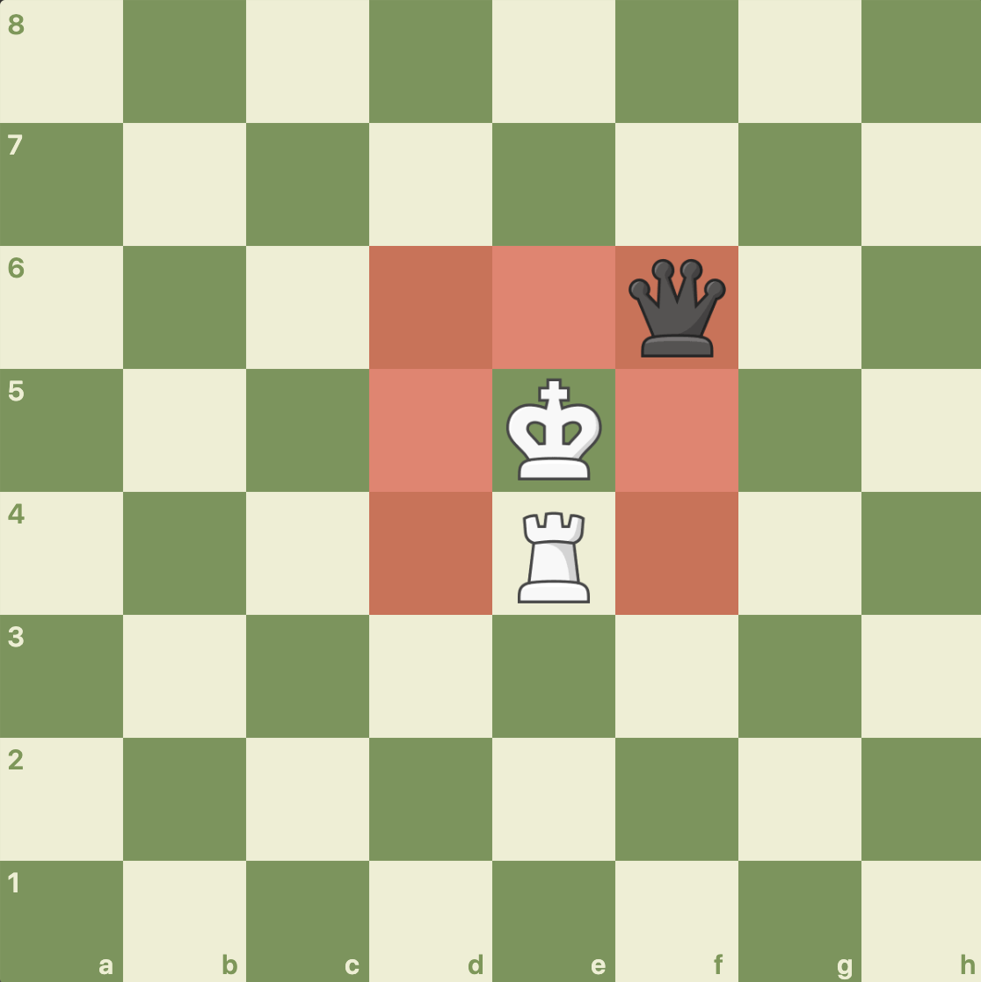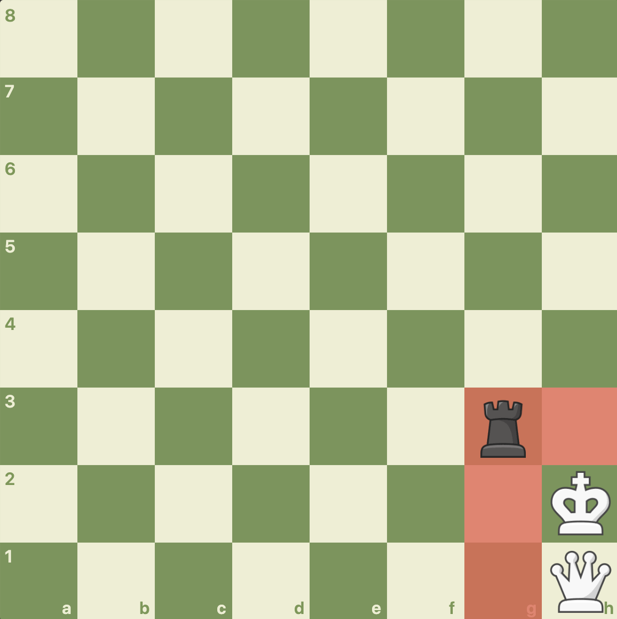

The test is grouped under testKingPieceIsLegalMove() in ChessTester.java::1076-1116. The test passed successfully.

PawnPiece, PawnMove, and EnPassantMove

## Introduction

This will cover all methods of the PawnPiece. In addition, PawnMove is fundamentally important to PawnPiece, so for PawnPiece’s methods isLegalNonCaptureMove(int row, int column) and isLegalCaptureMove(int row, int column), I will first test PawnMove’s respective methods and then test PawnPiece’s methods. In addition, EnPassantMove will also need to be tested, specifically to make sure that en passant can only take place after the immediate move of 2 spaces. PawnMove will also have to be tested to make sure that the 2 spaces move only happens during the first move of that pawn. Checking pawn promotion will also happen in this class, although the actual processing of what piece the user picks will happen in EuropeanChess and ChessBoard. In addition, setCanEnPassant() and getCanEnPassant() should also return the correct values. We will use this in conjunction if a moveDone() function of another piece to make sure the en passant values are being set correctly.

EnPassantMove::isValidEnPassantMove()

For the first test, I will be testing EnPassantMove. EnPassantMove is perhaps the most complex move because we have to test in all directions and make sure it is available once. First, I will put the kings and rooks in the right spot and test the en passant moves in all 4 directions. Then I will call moveDone() on a piece which should disallow any en passant moves. I will then test incorrect rows/columns to make sure that the en passant move cannot happen.

So first, I will check en passant moves, starting with West and East and then going to North and South. The 2 positions are shown below. The red highlighted squares indicate a successful en passant move. To do this, I will add the pieces and then call the moveDone() function on the pawn to be capture en passant, which should allow it to be capture only for the next move only. I will then do this for the other side.

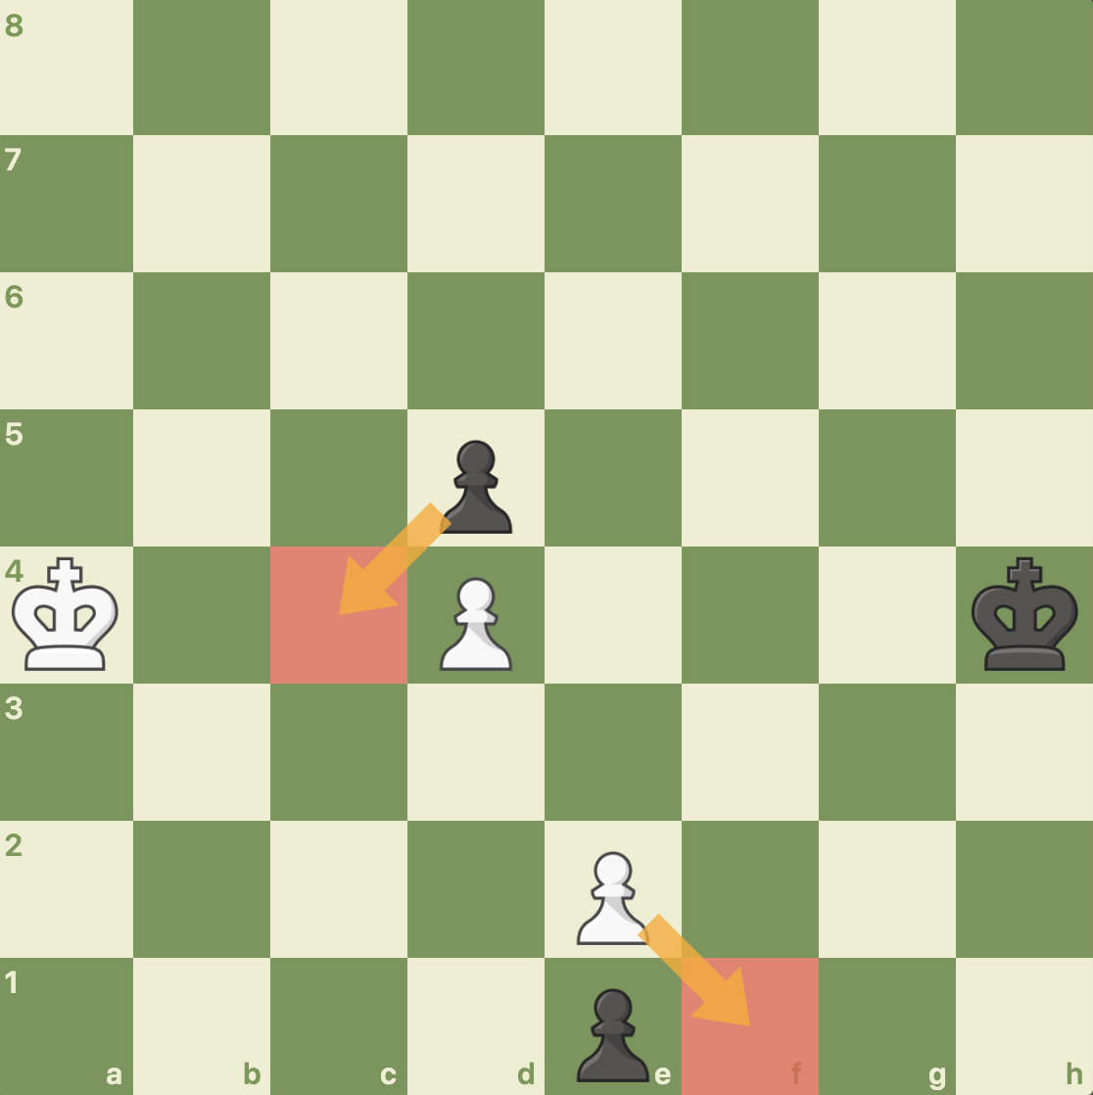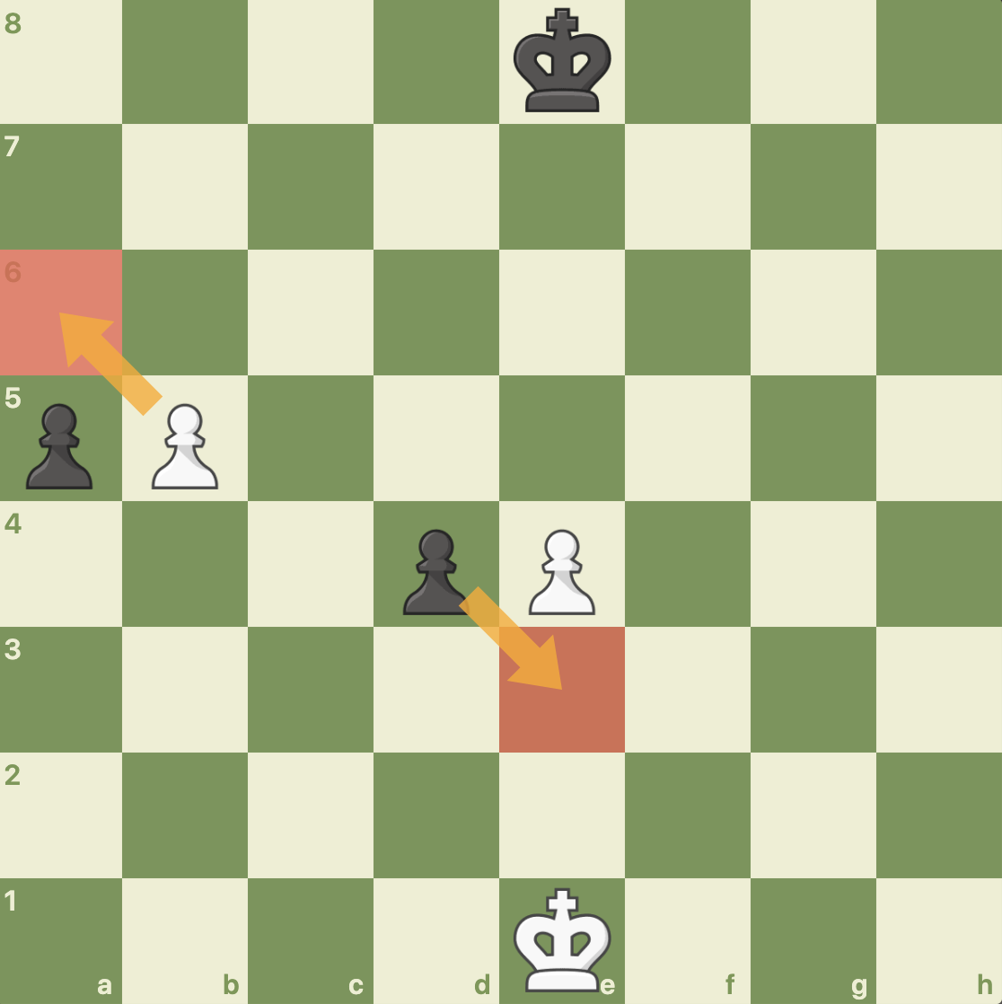

Next, I will call the moveDone() function which should disallow any en passant moves.

The test is grouped under testEnPassant() in ChessTester.java::1123-1241. The test passed successfully.

PawnMove::isValidPawnNonCaptureMove()

For the second test, I will be testing the PawnMove methods which checks if a non capture move can be made at that location. A PawnPiece can move forward 2 spaces if it’s the first move. I will test this by making a PawnPiece at the 2nd row of the board (corresponding to the side) and one on the side of the board, as shown below. I will check this for each of the sides. I will then reset the board to the below position and call the moveDone() function, and the pawn should only move 1 space. I will then place a piece in front of the pawn, and the pawn should not be able to move.

So first, I will test each pawn in its starting position for 2 directions, as shown below. The legal moves are highlighted in red:

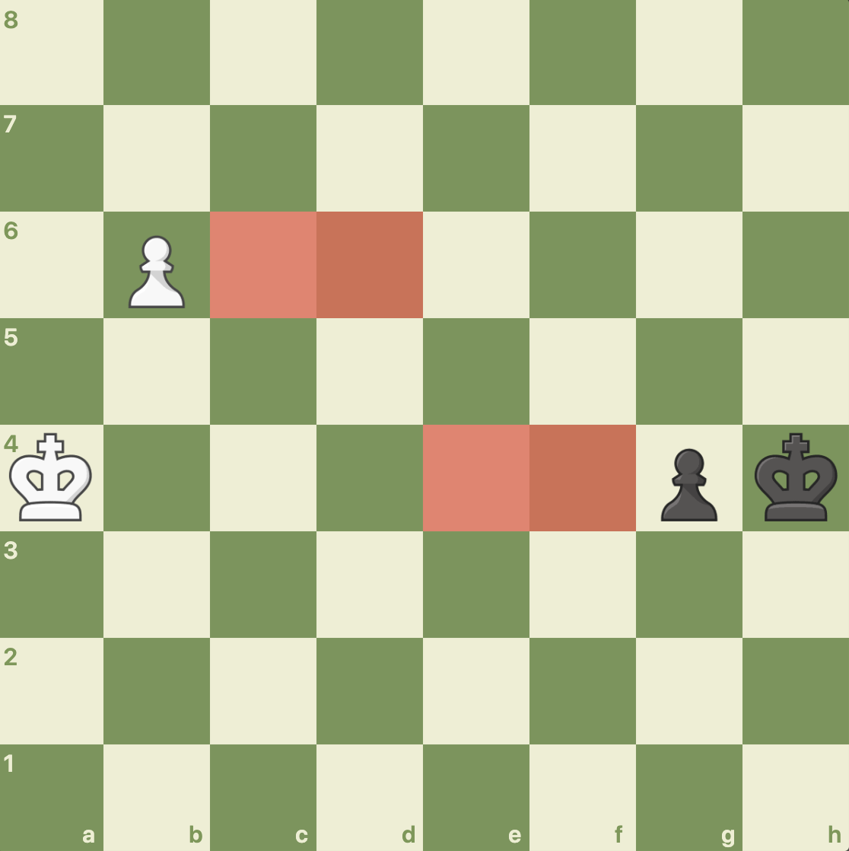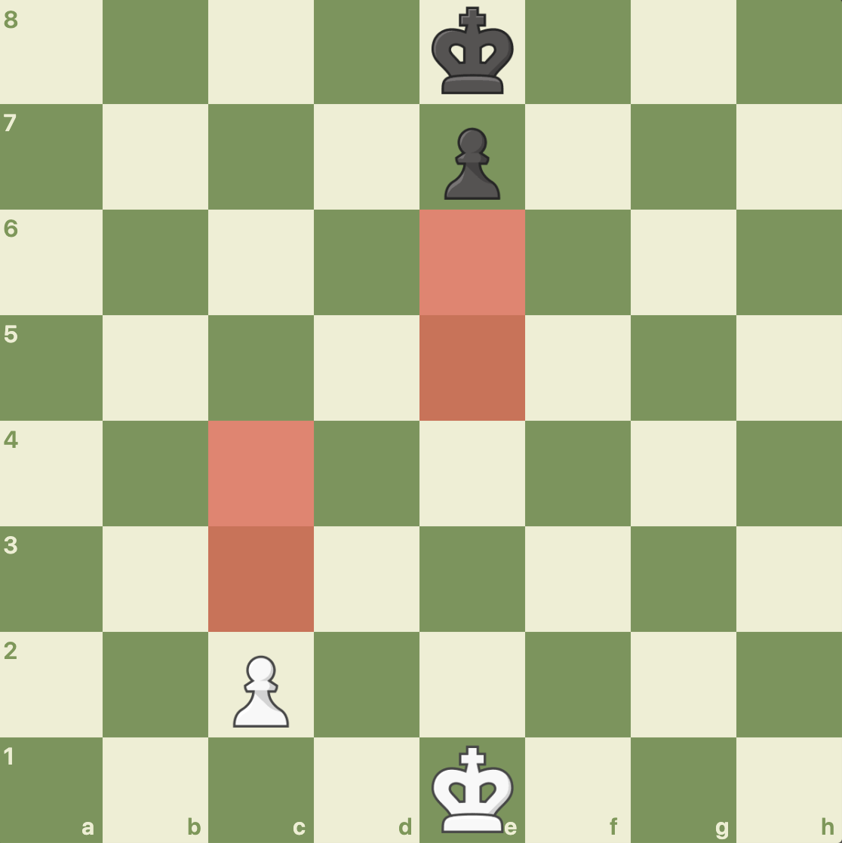

Second, I will test to make sure that the PawnPiece moves only for a single move instead of a double move. This is shown below:

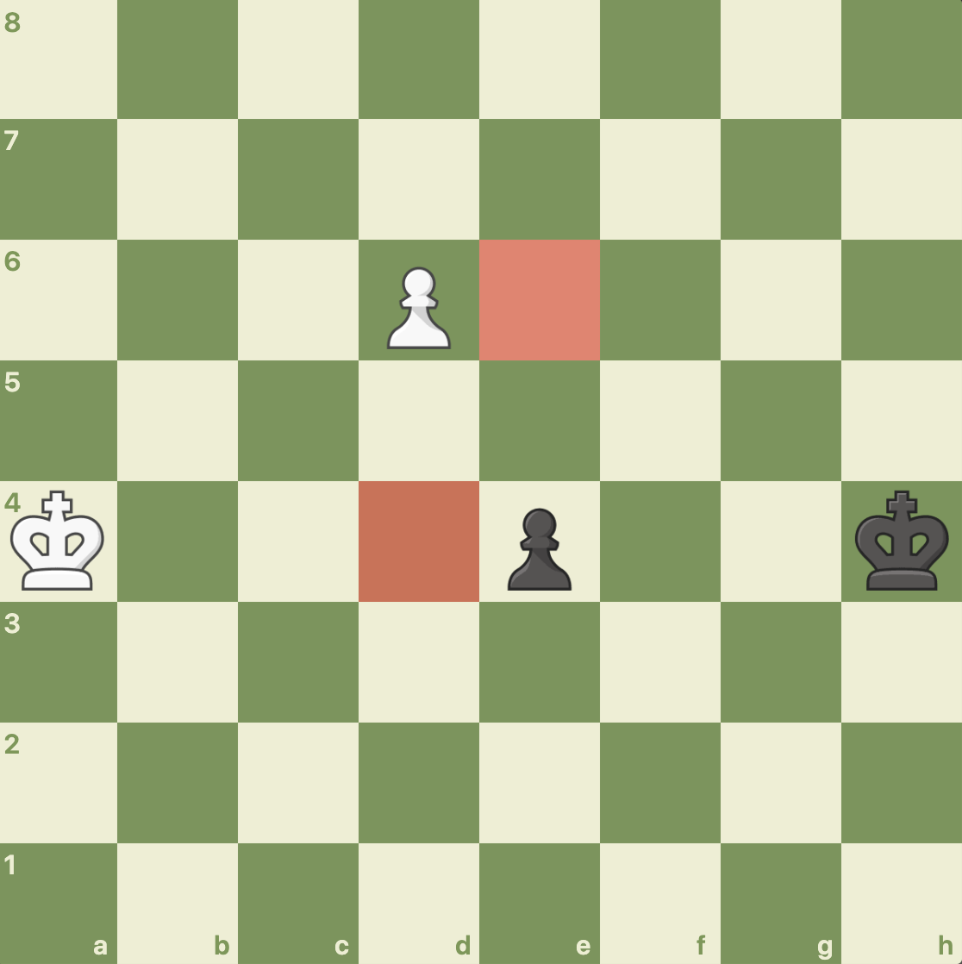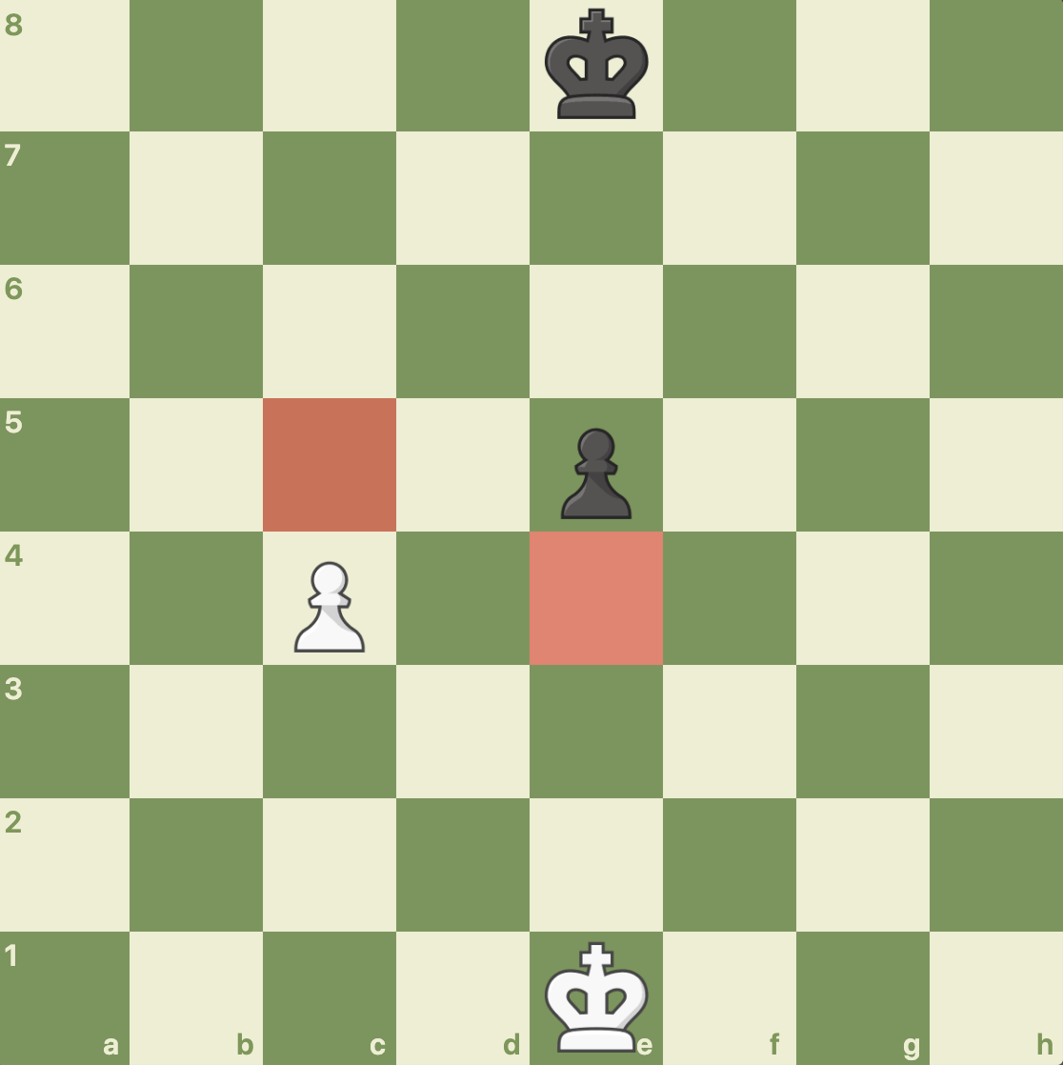

Lastly, I will put a piece in front so that the pawn cannot progress, as shown below:

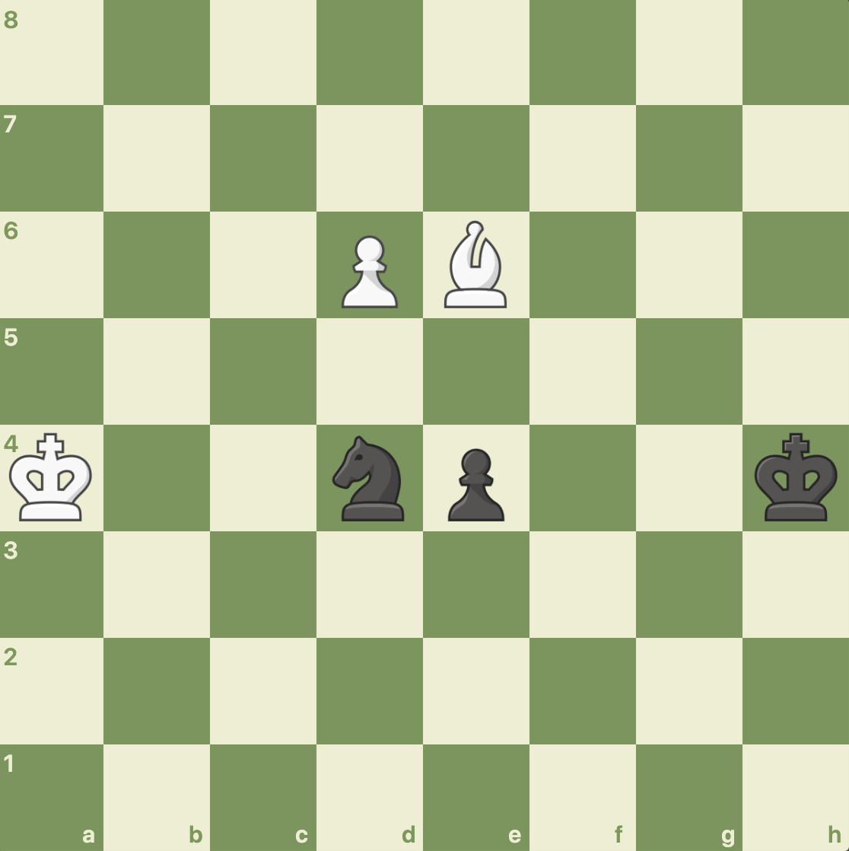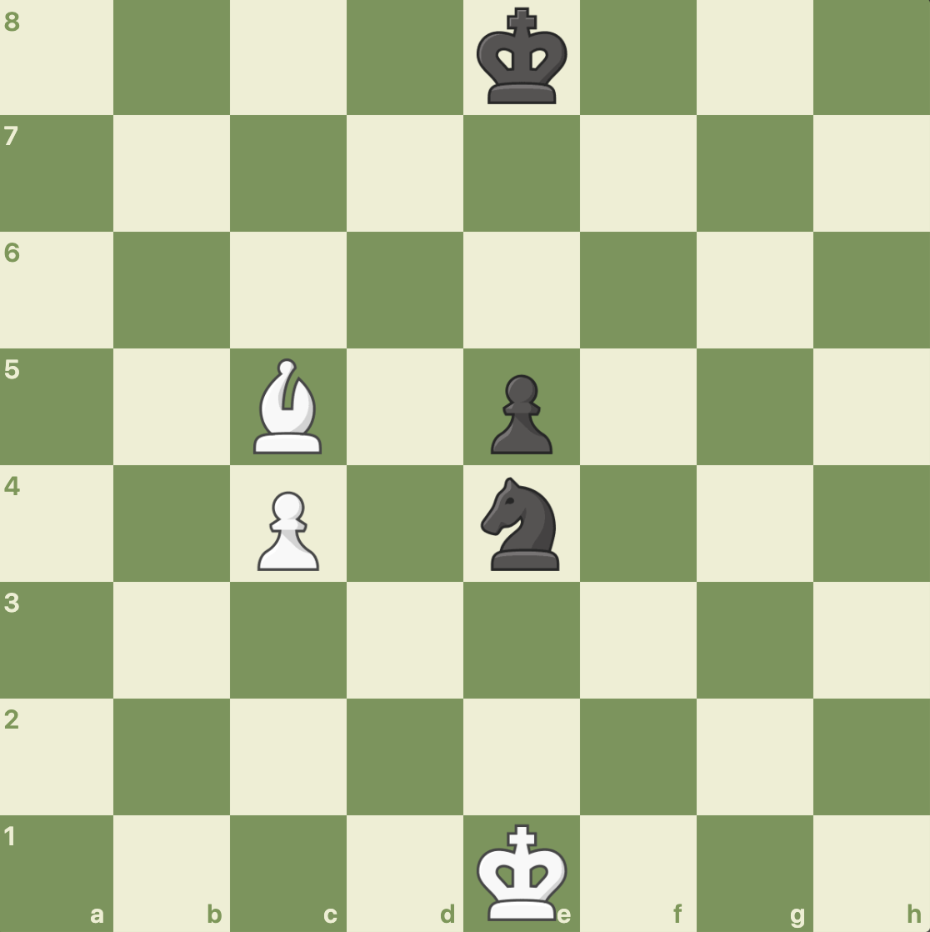

The test is grouped under testPawnNonCaptureMove() in ChessTester.java::1239-1405. The test passed successfully.

PawnMove::isValidPawnCaptureMove()

For the third test, I will be testing the PawnMove methods which checks if a capture move can be made at that location. A PawnPiece can only capture diagonally and only if the opposing chess piece exists. I will test the 2 positions below:

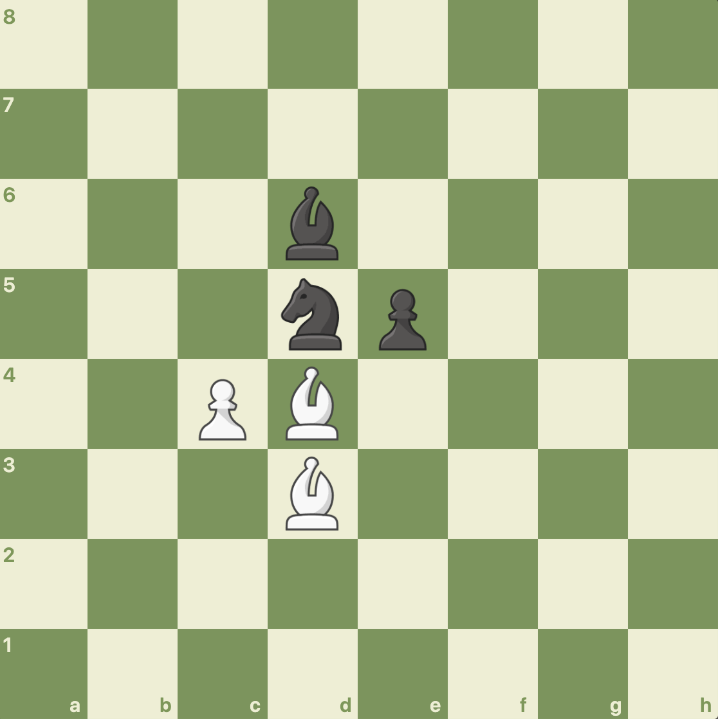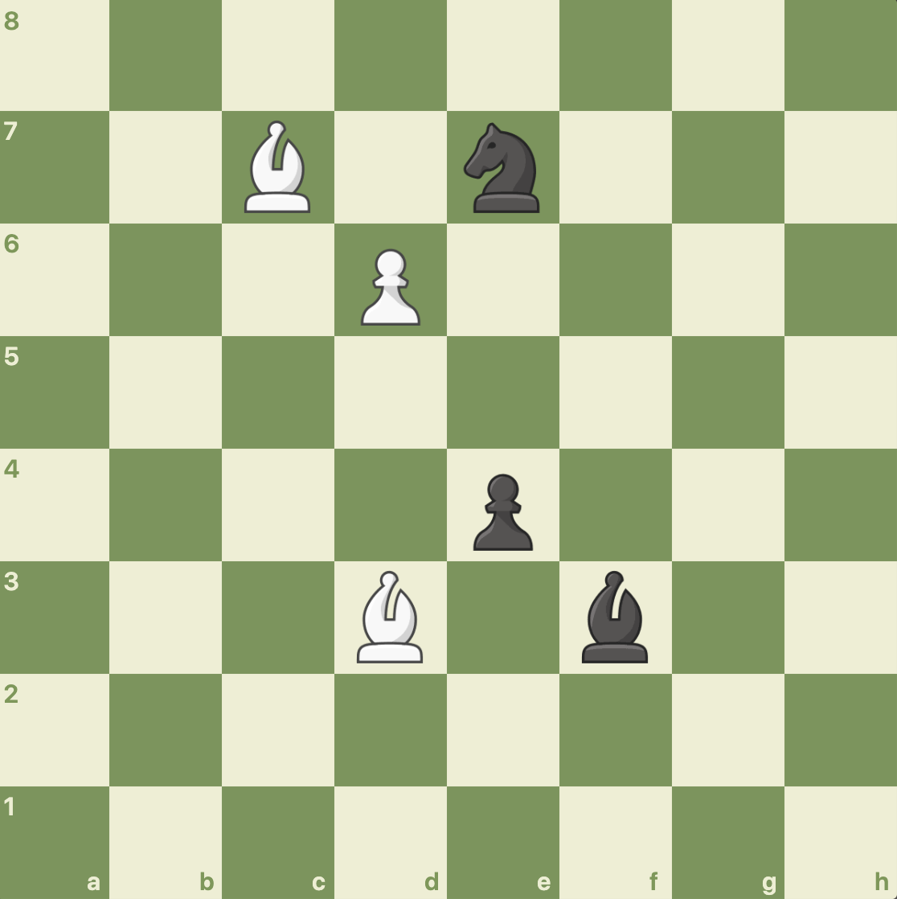

The red highlighted squares below should return true for isValidPawnCaptureMove():

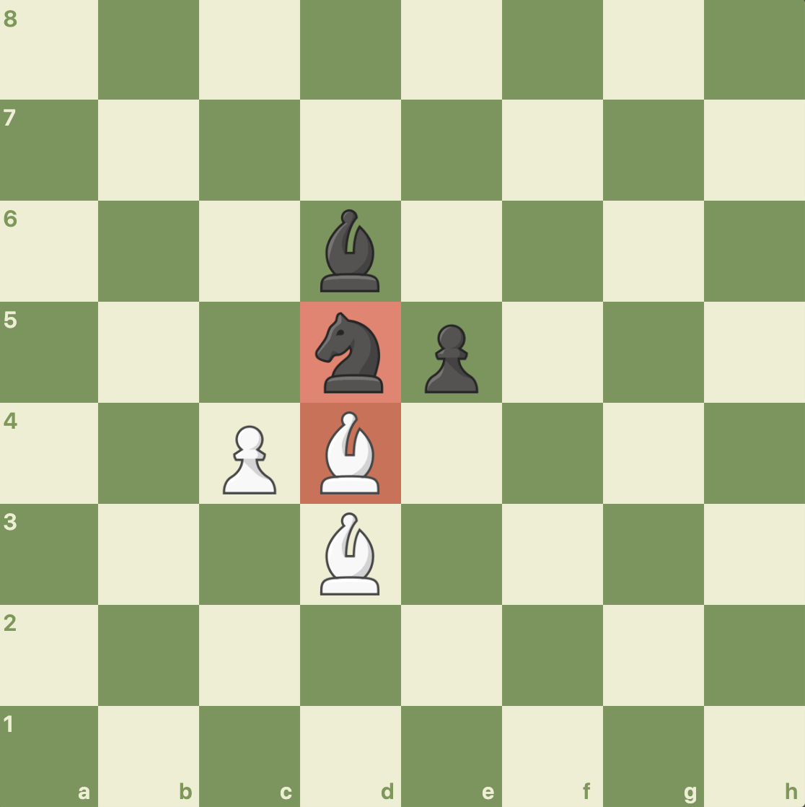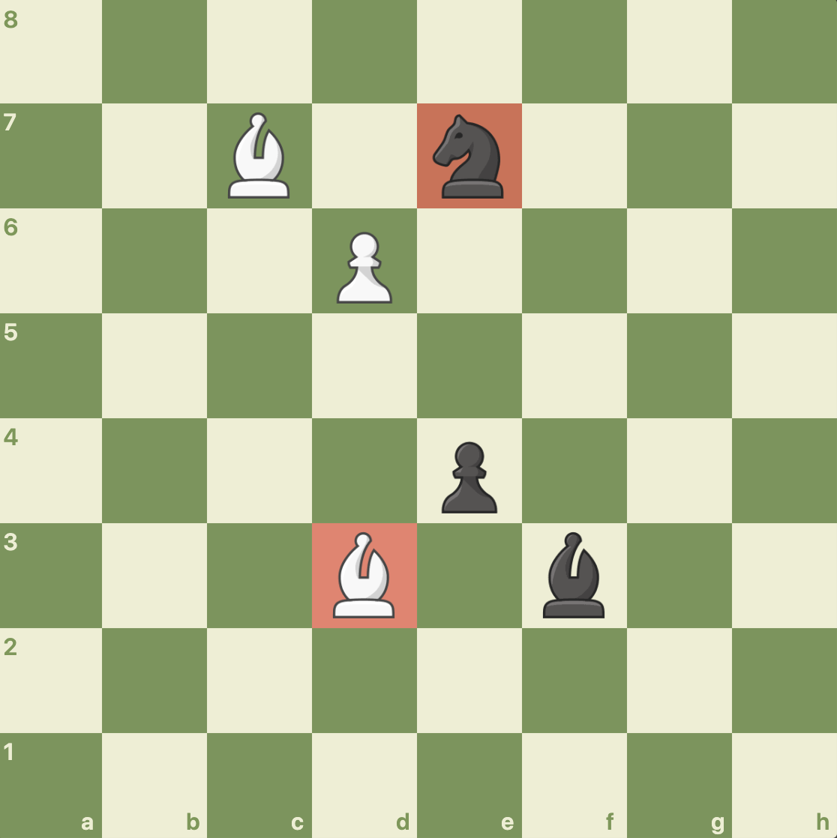

The test is grouped under testPawnCaptureMove() in ChessTester.java::1412-1478. The test passed successfully.

PawnPiece::PawnPiece(), PawnPiece::getCanEnPassant(), PawnPiece::setCanEnPassant(), and PawnPiece::moveDone()

For the fourth test, I will be testing the getter and setter methods for canEnPassant, which is unique to the PawnPiece class. I will first make a new PawnPiece, call getCanEnPassant() which should return false, call moveDone(), and then call getEnPassant(), which should then return true. Then I will set the canEnPassant using setCanEnPassant() to false and call getEnPassant() which should return false.

The test is grouped under testCanEnPassant() in ChessTester.java::1485-1495. The test passed successfully.

PawnPiece::checkPawnPromotion()

For the fifth and final test, I will be testing if the PawnPiece can be detected for promotion properly. To do this, I will create a new PawnPiece starting with side South. I will set the location around and only when the pawn is on the other side should it return true. I will then repeat this for each side, going to west, north, and east.

The test is grouped under testCheckPawnPromotion() in ChessTester.java::1502-1562. The test passed successfully.

EuropeanChess

## Introduction

This will cover all the methods in the EuropeanChess class. For the purpose of this project, I will NOT be testing additional logic methods like check() because these are not within the scope of the project. I will only be testing the required methods listed in the ChessGame interface plus the constructor and required getter and setter methods. I will additionally test promote() as well.

EuropeanChess::EuropeanChess(), EuropeanChess::getStartingSide(), EuropeanChess::getCurrentSide(), and EuropeanChess::flipSide()

I will be testing if the EuropeanChess class can be instantiated properly. To do this, I will instantiate EuropeanChess with a ChessGame.Side, and then use getCurrentSide() to get the side. I then will flip the side using flipSide() and then use getCurrentSide() which should change.

The test is grouped under testEuropeanChess() in ChessTester.java::1485-1495. The test passed successfully.

EuropeanChess::makeMove()

I will be testing if the EuropeanChess class can make a proper move. I will do this by testing each type of move: castling, pawn non capture, pawn en passant, regular capture, and regular non capture move. All of these should return true. Additional visual confirmation will be provided as well. The below is the initial setup and final position of the chess board before and after the test took place. All moves were performed correctly.

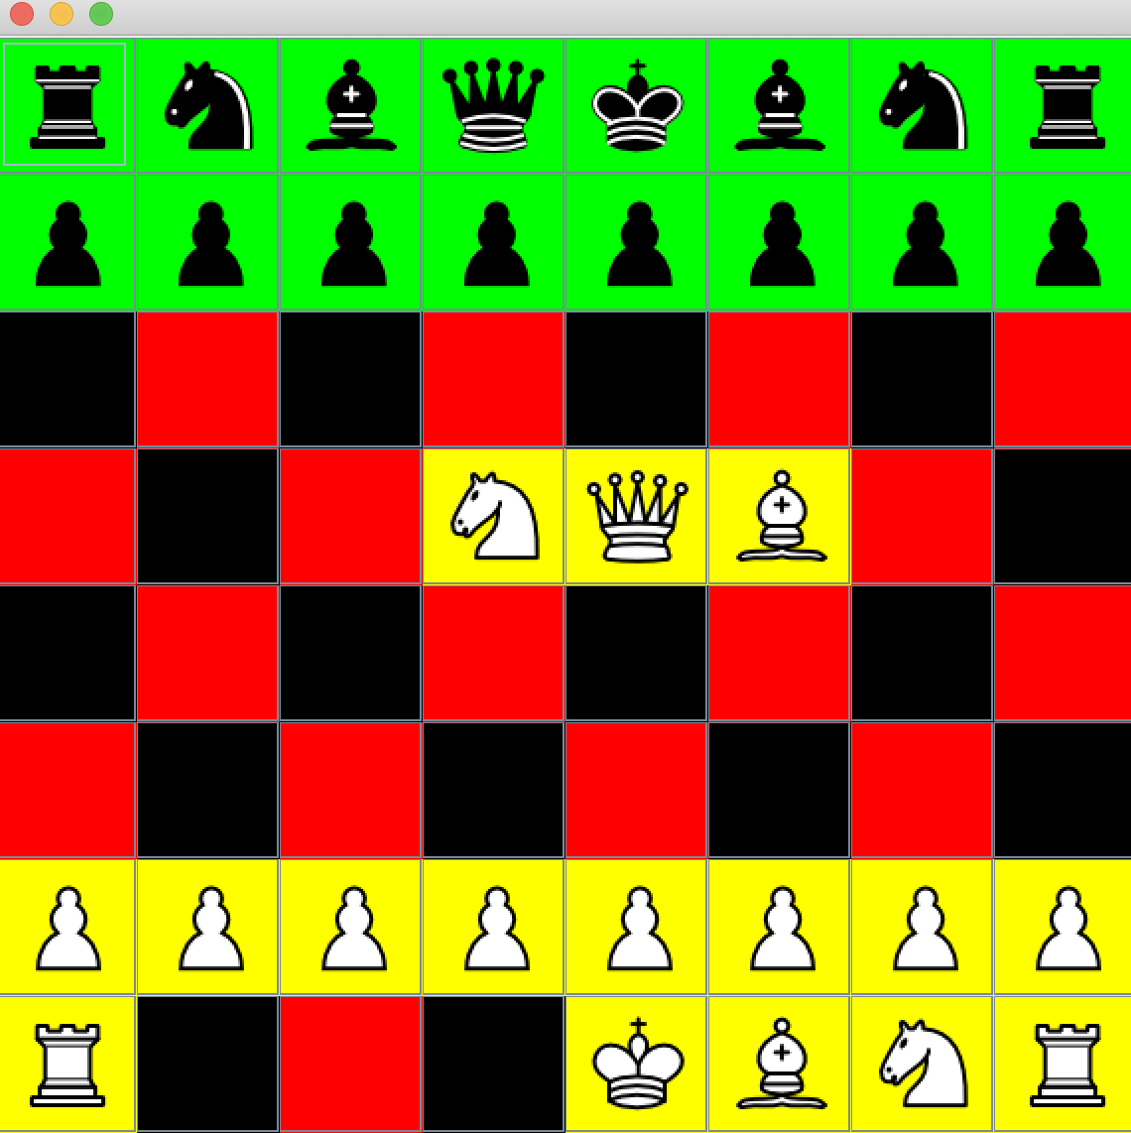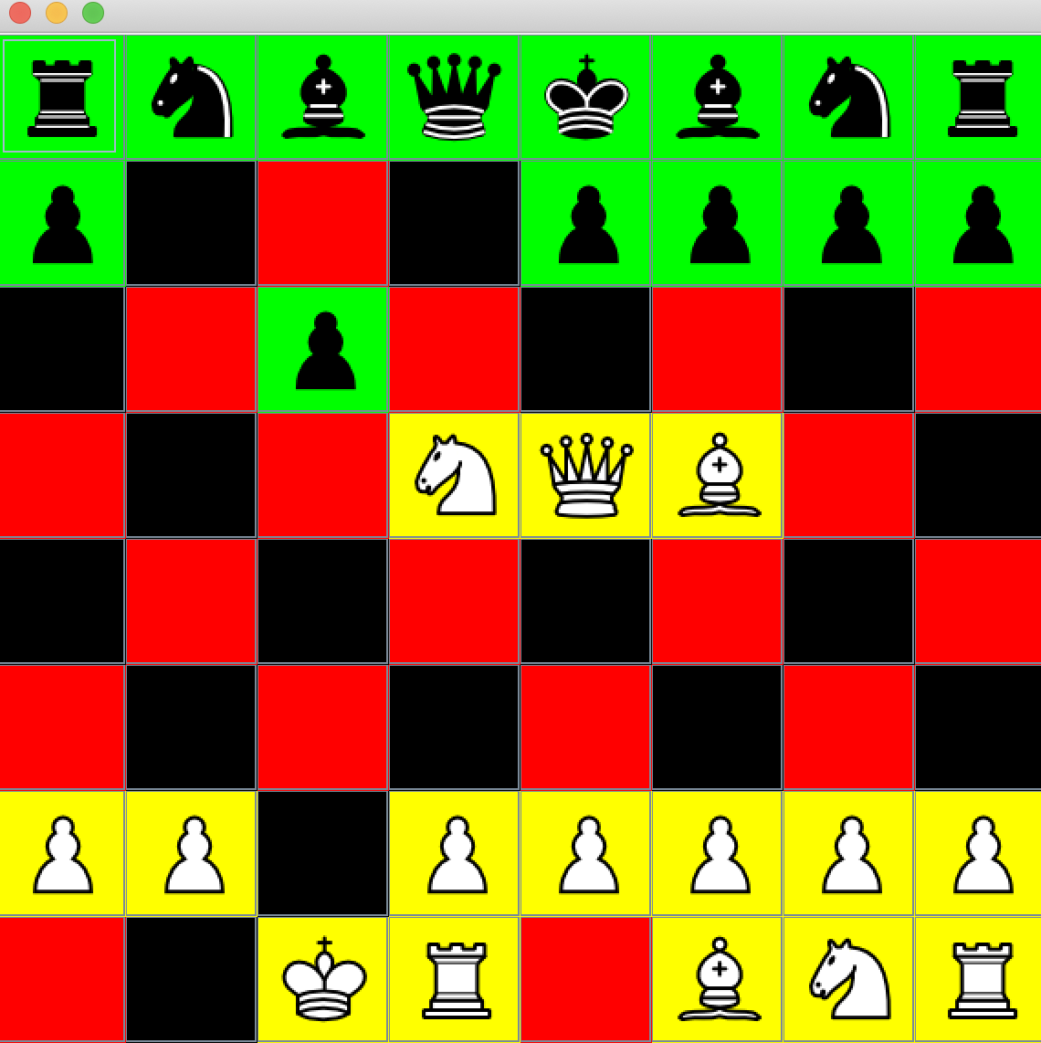

The test is grouped under testMakeMove() in ChessTester.java::1585-1633. The test passed successfully.

EuropeanChess::legalPieceToPlay()

I will be testing if the EuropeanChess class can check if a piece can be played. I will do this by testing each piece at a beginning of the chess game. The only pieces that should be allowed to move are the white knights and pawns.

And that’s all, folks!